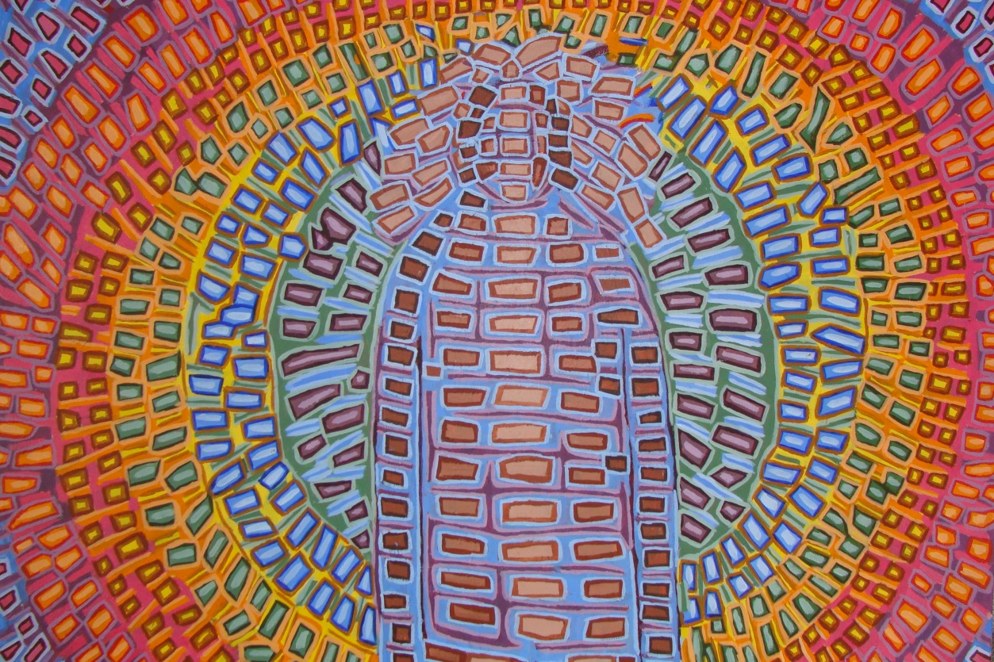

Meditation Class Info Handout
(Version: 10-20)

For online information outside of this class, see

www.Meditationary.org,
www.MedDict.org or www.MeditationDictionary.org.
A Dictionary of Meditation Practices

A-Z, with Helpful Guides

Copyright Information: The picture above, Angel, is © by Gabriel Jewell, All Rights Reserved, permission to use granted to Richard Jewell. Other images in this handout may be copyrighted, too. They are used here free for teaching purposes only. You may distribute them free for teaching, too, but if they are copyrighted, get permission for other uses. All non-picture-related text is by Richard Jewell: you may use any such text freely, but please give credit and the web address.
Meditation Suggestions–What Can You Do?
Western and Eastern Methods, for Class or Home (R. Jewell, 2-20)
- Body Position: Sit, stand, lie, or walk alertly, head and shoulders relaxed and even, back
slightly arched, spine straight, eyes closed or open. Adjust at any time; scratch an itch if needed.
- Breath: Breathe in a slow, regular pattern with both chest and stomach. Change as you will.
III. Focus (options):
- Conscious Awareness:
- Be aware and wait: see what happens in a flow without becoming attached to any of it.
- Become conscious of your awareness: keep turning your awareness on itself.
- Imagine yourself (or be) in nature; imagine an Awareness in, around, or above it all.
- Say “No” to each thought, image, or memory that comes to mind, except awareness itself.
- Mind and Mental Focus:
- Pray verbally–or with images and words–in your head.
- Repeatedly use a word or phrase special to you: e.g., “Peace,” “Aum,” or “God is Love.”
- Remember and concentrate on an image or sound special to you.
- Remember and focus on a special uplifting experience or feeling.
- Concentrate on a color that is, to you, uplifting, energizing, or safe.
- If troubling thoughts/emotions come, dive into them and watch them as they proceed.
- Choose an idea; then hold it centrally in your mind as a single concept, image, or phrase. See what comes to it or is attracted to it, without your becoming attached to any results.
- Concentrate on a point 1-2 inches (or 10-14 inches) above the central crown of your head.
- Body, Senses, and Physical Feelings:
- Focus on just your breath using a count: e.g., a count of three or four breathing in, and three or four breathing out; or a rhythm of three in, three out, and three resting; or similar.
- Concentrate on your heart–or beside it on the middle-front of your chest. Rest in it.
- Focus on relaxing a troubled part of your body. (You may, if you wish, start with an easy-
to-relax body part, then transfer that feeling of relaxation to the troubled part.)
- Imagine a ball of white, green, or purple around or in a troubled part of your body.
- Imagine all of you is surrounded by a peaceful, energetic, and healing oval or sphere. If you wish, make it clear, white, green, purple, or any bright color you wish.

- Relax your eyebrows, jaw, shoulders, and throat (let it expand) so your thoughts slow.
- Imagine you are dancing in liquid air. Feel your muscles and limbs swaying to music.
- Imagine you are enjoying a relaxing, pleasant bath, or shower, or swim. Feel the water around you. Imagine you let it flow inside of each part of you. Let your body become water.
- Focus on a favorite sound or scent that brings you calmness and greater inner awareness.
Yoga (from Hinduism) (R. Jewell, 10-20)

“Yoga” in Sanskrit (Asian Indian) means to “yoke” yourself to higher energies. Many versions of it exist. The first mention of it is in the earliest Hindu scriptures, the Vedas, which were created between 12,000 and 3000 BCE. There are many branches, “schools,” and methods of yoga. Here are some of the most basic, general types:

Hatha Yoga: Hatha or physical yoga–exercises and stretches–is ancient. Hatha is what is best known as “yoga” in the West, where it sometimes involves simple exercise and stretching, and more often is combined with at least some kind of meditation (often called “mindfulness”). In the East, most forms of physical yoga also involve meditative or mindful states.

Raja Yoga: Raja yoga or “royal” yoga involves mental concentration at the crown of the head or above it. This focus point is said to be for mystics or saints, or for others who want to experience higher-level energies or move faster through or into such states.

Patanjali’s Yoga: Patanjali (or Patanjah) lived sometime between 200 BCE-400 CE. His “Yoga Sutras” (or “Yoga Aphorisms”), best known in the West, were the first ever written yoga instructions to clear the mind for finding an underlying awareness.

Tantra/Chakra/Kundalini Yoga: Tantra yoga involves seven “chakras” or energy centers, from the ancient Hindu health system. They are: crown, third eye, throat, heart, solar plexus, spleen, and base-of-spine center and are used for meditation. See p. 5.

Jnana Yoga: Jnana yoga is “knowledge” yoga. It involves concentration on the “third eye” nerve center between the eyebrows and/or the throat nerve center in the hollow of the throat. The third-eye center is related to visualizing; the throat, to sound. Jnana yogis may study scripture, visualize objects or colors, or focus on or create sounds or specific words.

Mantra Yoga: Mantra yoga is a subset of Jnana Yoga using the repetition of helpful words, phrases, or sounds to guide one to deeper meditation: e.g., “Om” or “Peace.”

Bhakti Yoga: Bhakti or “love” yoga is the most practiced yoga in India. Practitioners may concentrate on the heart nerve chakra–in the middle of the chest beside the heart, or in the heart itself–or devote themselves to loving, joyous rituals or service, or to beings who personify love.

Karma Yoga: Karma yoga means material or work yoga. Those who practice it devote themselves to work that is holy or helps others, giving this work to a higher, deeper presence.

Buddhism (R. Jewell, 10-20)

Buddha: Buddhism is the fourth largest religion in the world. Buddha was born about 500 or 400 BCE (scholars disagree) as a prince in a very wealthy family. Legend says he was kept from seeing suffering when he was young, and as a young man he lived a life of study and of sensual indulgence.
However, at some point he became aware that everyone experiences the suffering of birth, sickness, aging, and death. He decided to give up his riches and become a wandering monk who tried different forms of meditation.
Over the years, his meditations became increasingly, harshly ascetic (hours of meditation in sometimes painful positions, a minimum of clothes, plain food, exposure to bad weather, etc.) until his many followers dwindled to just a few. At that time, he sat under a tree until he experienced Nirvana (liberation, enlightenment, or loss of all attachment). He then spent his life practicing and teaching a “Middle Way” of liberation, one of neither excessive pleasure or pain.
Buddha’s “Four Truths for the Noble” (also called “The Four Noble Truths”):
Buddha offered these four truths in his first sermon after his enlightenment.
- Life has suffering. The simple act of living brings suffering and lack of knowledge.
- There is a cause of suffering. We are too attached to our lives, bodies, and selves.
- There is a way to end attachment. This way is liberation or enlightenment: Nirvana.
- There is a path to this liberation. It is the “Eightfold Path” or “Middle Way.”

Buddha’s Eightfold Path or Middle Way:

- Right view or understanding. Don’t always get caught up in everything. Relax. Watch.
- Right resolve or thought. Learn to think positively or neutrally.
- Right speech. Be responsible for how your speech affects yourself and others.
- Right conduct or action. Act fairly, rationally, and kindly, or at least neutrally.
- Right livelihood. In your job, be ethical and make the world a better place.
- Right effort. Become increasingly focused on being a better, deeper person.
- Right mindfulness. Be increasingly aware of what you do and think, and what you are.
- Right concentration. Use meditation to detach from suffering, and find deeper and greater peace, joy, and strength.

Nirvana: “Nirvana” is a Sanskrit word meaning “disappearance” or “crossing out” of the normal self. In Nirvana, thoughts and feelings don’t necessarily stop, but you are liberated from them. Nirvana can first come suddenly; or it can slowly build–or be built–in meditation.
Buddhist Schools of Practice (R. Jewell, 10-20)

Buddhism, like all major religions, is divided in to several major groups. Here are some of these divisions and how they practice meditation.

Theravada Buddhism (“Thera Vada”: “School of the Elders”): Theravada is the oldest and most original division of Buddhism, now predominantly in India and Southeast Asia. Meditators use some of the oldest surviving scriptures of Buddha’s teaching (the “Pali” canon; Buddha himself only taught by oral lecture), often in classic monasteries with strict religious discipline. Meditation practice may consist of focusing on one object, idea, or mantra as a method to calm the mind; and on becoming sufficiently calm within to identity the basic forms or shapes of inner realities. Some use loving kindness and compassion regularly.

Mahayana Buddhism (“Maha Yana”: the “Great Vehicle”): In this type of Buddhism, which is one of three later main divisions, meditators work on their personal enlightenment, they believe anyone can attain it, and they encourage it in the world.

Zen Buddhism: Zen Buddhism is a Japanese version of Mahayana Buddhism (developed first in India, then China, as “Chan” Buddhism). Zen especially prizes saying “no” to the busy outside world, consideration of nature, and focusing on denying all but what true awareness itself provides.

Sravakayana Buddhism (“Sravaka Yana”: the “Disciple Vehicle”): In this second, later division, meditators tend to work primarily on their own personal enlightenment and on detaching from life. Meditators tend to live in monasteries or alone in ascetic withdrawal. Sometimes this, or a general type like it, is called “Hinayana Buddhism,” which means the narrow path, but may Sravakayana Buddhists consider “Hinayana” a negative term.
Vajrayana Buddhism (“Vajra Yana”: the “Diamond or Thunderbolt Vehicle”): Sometimes this is seen as a division of Mahayana, but often it is considered a third, separate, and later division. Meditators use mantras (words & phrases), visual images, ritual chants, and hand and finger positions to remember Buddha, find the inner true self, follow Buddhism’s work of clearing oneself, or practice non-attachment.
Tantra Buddhism: This is a type of Vajrayana Buddhism. It is especially famous in its Tibetan form. In China and Japan, “tantra” variations often include, and mean, “Secret Teachings.” Meditators use mantras (words & phrases), visual images, ritual chants, and hand and finger positions as above.

Chinese Buddhism: Several forms of Chinese Buddhism exist, following the above formats or formats of their own.

Christian and Jewish Inner Meditation (R. Jewell, 10-20)

Christianity and Judaism have long and varied traditions of meditation. Unfortunately, much of it has been lost. Here are several ancient and current traditions.

Praying: The most common tradition is prayer. In different versions of Christianity, prayer can be with words or wordless. It can be done by focusing on an object (e.g., a cross, a rosary, a picture), on an internal image (a picture or other visualization), or on a sound (e.g., a chant, a word, a song). Singing itself sometimes is used as a form of prayer, out loud or internally. Praying often takes place both individually and in groups.

Practicing Faith: In the Bible’s New Testament, faith often is discussed. Today, it usually is meant as an abstract word or a general idea about hope or belief. However, for early Christians, it was a dynamic form of meditation. When they exhorted each other to have faith, it was a call to open themselves to the presence of a higher power, or to look upward (internally) for that higher power.

Looking to Heaven: In the Old Testament, looking to Heaven was not an abstract word, place, or general idea. Rather, it was a call and recommendation to literally look up, internally or externally, imagining heaven as a higher place. This had the effect of making people focus above their own bodies on a higher point, just as Hinduism and Tibetan Buddhism suggest meditating on a point at the top of one’s head or above it.

Going Within: Early Christians also often were taught to meditate within, to find a deeper self and connection with holiness there. When Jesus said that the kingdom of Heaven is within, he meant that people literally should look within themselves to find their deepest self so they could connect with heaven. Similarly, perhaps the most respected noncanonical early Christian gospel, the “Gospel of Thomas,” which some scholars think may have been the source of sayings of Jesus in “Matthew,” “Mark,” and “Luke,” repeatedly recommends that people look within to find their holy individual self that connects to Heaven.

Using “Centering Prayer”: Centering Prayer is a new movement and meditation system among Catholics and Protestants. It teaches you to sit quietly without distraction, possibly starting with a brief prayer, and then wait in silence for a deeper awareness, ignoring all normal thoughts and feelings. Sometimes a “Sacred Word” is used that you choose as having deep, special, meditative meaning to you. Centering Prayer is similar to some types of Eastern practices such as Zen and Maitri Buddhism.

The Meaning of “God”: The original words for “God” in the Bible’s Old Testament were “Yahweh” (also spelled “Jehovah”) and “Elohim.” A literal meaning of “Yahweh” is “I Am that I Am.” The other word, “Elohim” can be translated roughly as “The male/female single/multiple God/s.” Some theologians have suggested that early Jewish mysticism encouraged people to focus on these names during meditation within.
Hindu and Tibetan 7 Chakras (Energy Centers) (R. Jewell, 2-20)

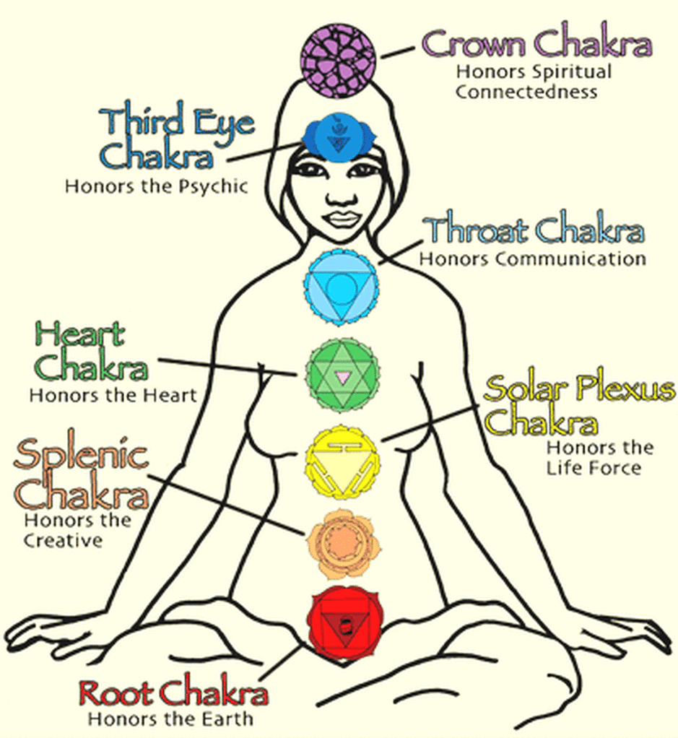  www.sebadamani.com/blog/kemet-and-the-aritus (retrieved Mar. 2019) | The Hindu chakras, or energy centers, are centers on the top, front, and bottom of the body where, science says, nerves come together. They are:  Top of the Head or slightly above it: the “spiritual” center.  Third Eye between and slightly above the eyebrows: visual thinking, seeing  Throat in the hollow of the throat: verbal thinking, talking, sound, song.  Heart in the center of the chest by the heart, or in the heart itself: love, emotional warmth, joy, happiness.  Solar Plexus where the halves of the rib cage come together: strength, will.
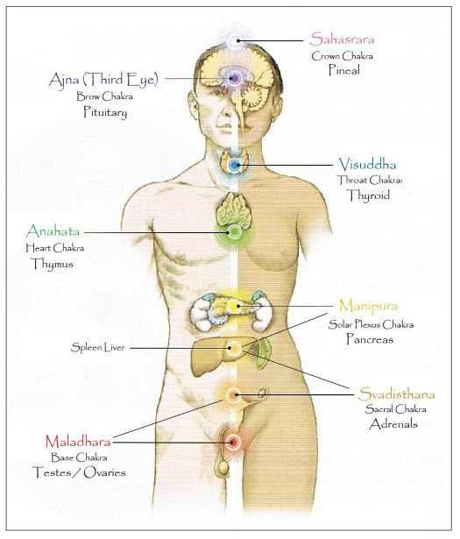  www.bellaonline.com/ArticlesP/art67596.asp (retrieved Mar. 2019) | Splenic/Liver or Healing below the navel: digestion, heavier emotions  Root or Base at the base of the spine: sex, matter, cells, darkness.  Traditional Method: Tibetan (and Indian) Kundalini Yoga says that an energy “snake” rises from the base chakra, opening each center as it goes. However, there are many dangers involved, including illness and insanity, and it should be done only under the guidance of a yoga master.  Independent Vedic Hindu Method: Simply practice Raja Yoga (concen-tration on the top chakra) or Bhakti Yoga (concentration on one of the heart chakras). Then you are opening “safe” energy centers with purer energies that then can travel down.
THE FIVE HINDU KOSHAS

Five Sheaths, Shells, or Layers of a Person in Vedantic Hinduism

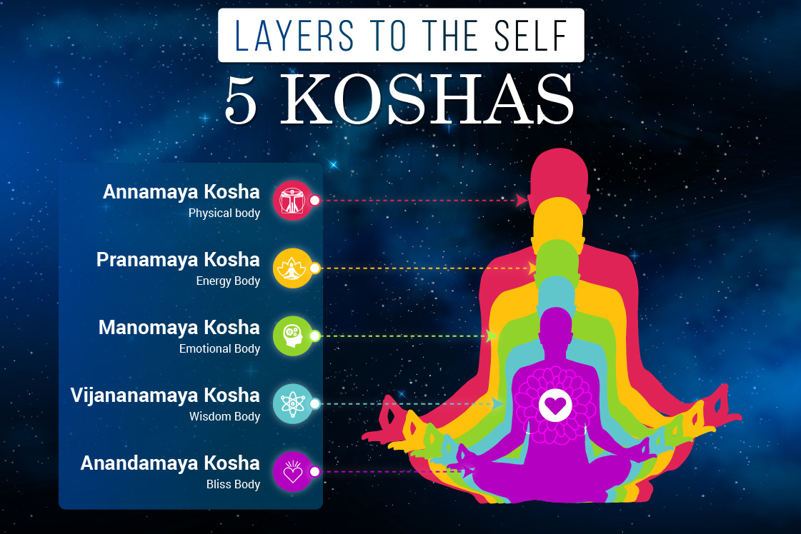
https://fitsri.com/yoga/koshas

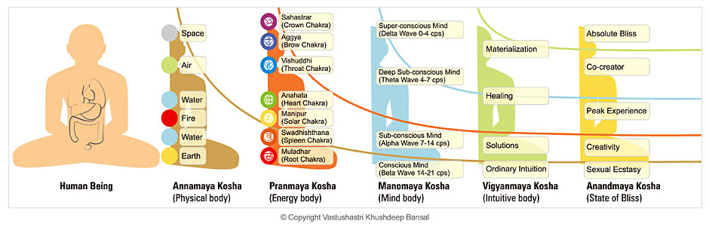www.thehealersjournal.com/2013/04/23/beyond-the-chakras-the-five-koshas-health-healing/
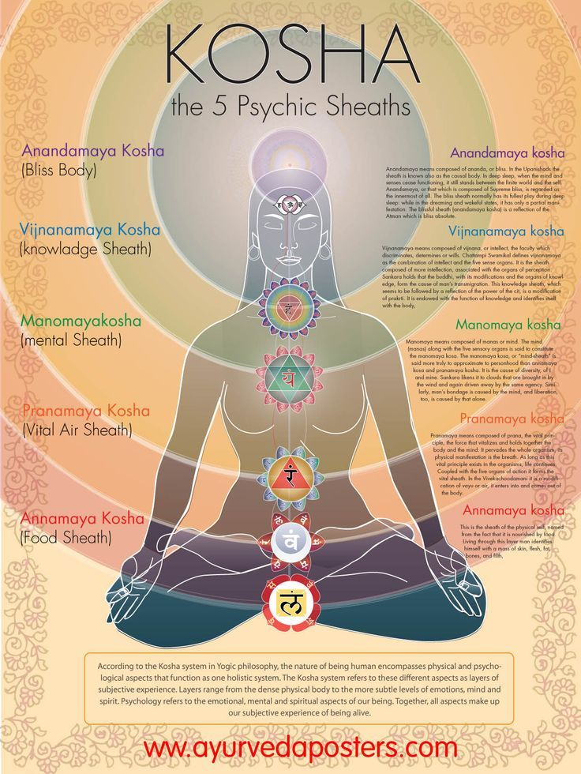
www.vasturemedy.com/five-layered-human-being/
Tibetan Buddhist 5-Wisdom Color Meditation (R. Jewell, 10-20)

Tibetan five-wisdom or five-color yoga, or maitri (“my-tree”) yoga, involves meditating in an environment with one color or related sensory realities at a time. Medi-tators rest in the color/elements and wait to see what happens within. The four spokes or quarters below represent the elements of earth, water, air, and fire, along with other real-world experiences that are part of them. The center area represents space, or emptiness. (Sometimes this fifth element is not used: “spirit” is in air).

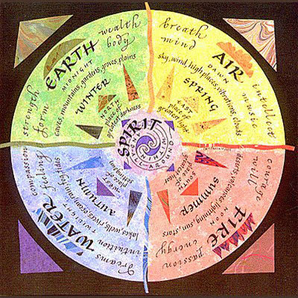
http://balkhandshambhala.blogspot.com/2012/12/balkh-five-elements.html (retrieved Apr. 2019)
From “The Healing Practice of the Five Elements Goddesses” composed by Tenzin Wangyal Rinpoche, and explained in his book Healing with Form, Energy and Light: The Five Elements in Tibetan Shamanism, Tantra, and Dzogchen.”

