Minnesota State |  | www.MnWE.org |  | Minnesota’s Private Colleges
Minnesota Writing and English
Conference Program
Connecting Landscapes

March 31 - April 1, 2017

Southwest Minnesota State University,
Marshall, MN

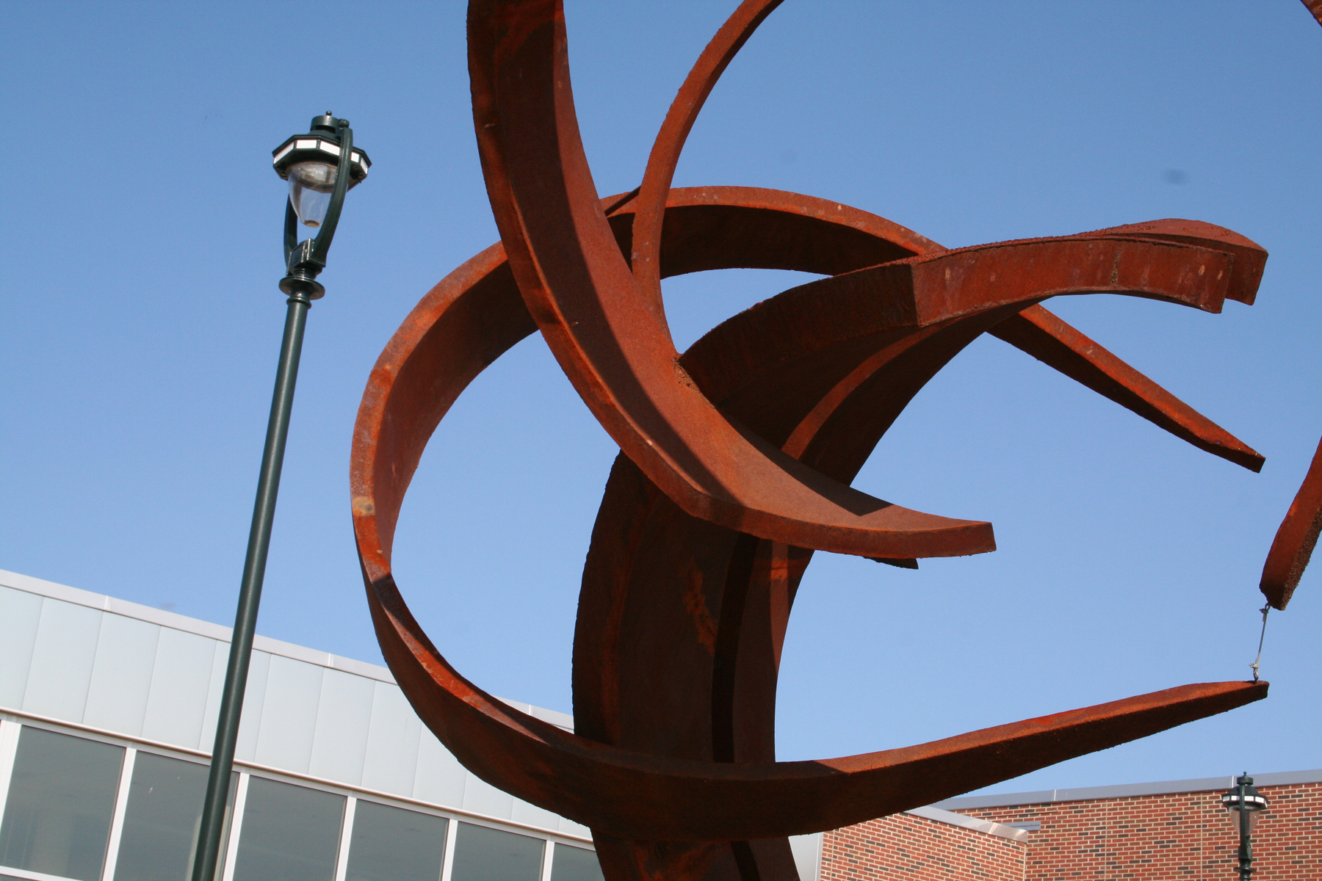

MnWE would like to express its thanks to Southwest Minnesota State University for its generous donation of conference space, the University of Minnesota Department of Writing Studies for regular donation of meeting space, and the Minnesota State Colleges and Universities for use of its Lyris Listserv program for the MnWE Newsletter.

MnWE Primary Coordinators
Richard Jewell | General Coordinator | Richard@jewell.net | (612) 870-7024
Larry Sklaney | Conference Co-Coordinator | larry.sklaney@century.edu | (651) 747-4006
Danielle Hinrichs | Conference Co-Coordinator | danielle.hinrichs@metrostate.edu | (651) 999-5960
Gordon Pueschner | Creative Coordinator | gordon.pueschner@century.edu | (651) 686-4468
Mary Ellen Daniloff-Merrill | Site Host Co-Coordinator | mary.daniloff-merrill@smsu.edu
Lisa Lucas Hurst | Site Host Co-Coordinator | lisa.lucas@smsu.edu

MnWE Committee
This first list contains MnWE Committee members who attend meetings regularly. Anyone may join the committee who is willing to serve as a volunteer in a significant capacity. Often (but not always) this service includes attending most of the MnWE Committee meetings. If you're interested, let us know, or join us for our meeting at the end of the conference!
David Beard, University of Minnesota-Duluth, dbeard@d.umn.edu
Heidi Burns, Minnesota State University-Mankato, heidi.burns@mnsu.edu
Alexander Champoux, University of Minnesota-Twin Cities,
Kirsti Cole, Minnesota State University-Mankato, kirsti.cole@mnsu.edu
Anthony Collins, Inver Hills Community College, acollin@inverhills.edu
Julie Daniels, Century Community and Technical College, julie.daniels@century.edu
Mary Ellen Daniloff-Merrill, Southwest Minnesota State University, mary.daniloff-merrill@smsu.edu
Dan Darling, Normandale Community College, Daniel.Darling@normandale.edu
Anna Davis, Hennepin Technical College, anna.davis@hennepintech.edu
Melissa Giefer, Winona State University, mgiefer@winona.edu
Danielle Hinrichs, Metropolitan State University, danielle.hinrichs@metrostate.edu
Richard Jewell, Inver Hills Community College, richard@jewell.net
Yanmei Jiang, Century College, ymjiang2008@yahoo.com
Darryl Johnson, Anoka Technical College, daugustj@gmail.com
Lisa Lucas Hurst, Southwest Minnesota State University, lisa.lucas@smsu.edu
Anthony Miller, North Hennepin Community College, anthony.miller@nhcc.edu
Lynda Milne, MnSCU Faculty Development, Lynda.Milne@so.mnscu.edu
Beata Pueschner, Anoka Ramsey College, beata.pueschner@anokaramsey.edu
Gordon Pueschner, Century College, gordon.pueschner@century.edu
Donald Ross, University of Minnesota-Twin Cities, rossj001@umn.edu
Larry Sklaney, Century Community and Technical College, larry.sklaney@century.edu
Linda Tetzlaff, Normandale Community College, linda.tetzlaff@normandale.edu
Joan Thompson, Normandale Community College, joan.thompson@normandale.edu
Pakou Yang, MnSCU Central Offices, pakou.yang@so.mnscu.edu

Contact Representatives

This second list contains representatives of MnWE at their schools, who pass MnWE communications on to their departments and other interested members. If you would like to serve as a representative of MnWE for your department and no one else is doing so, please let us know!
Brian Baumgart, North Hennepin Community College, brian.baumgart@nhcc.edu
Laura Benda, Institute of Production and Recording, lbenda@ipr.edu
Mary Ellen Daniloff-Merrill, Southwest Minnesota State University, mary.daniloff-merrill@smsu.edu
Anna Davis, Hennepin Technical College, anna.davis@hennepintech.edu
Lee-Ann Kastman Breuch, University of Minnesota, lkbreuch at umn.edu
Kristin Buck, Rochester Community and Technical College, Kristin.Buck@roch.edu
Kay Dailey, University of Wisconsin-La Crosse, dailey.kath@uwlax.edu
K.C. (Kenneth) Hanson, Minn. State Comm. and Tech. College, k.c.hanson@gmail.com
Brandy Hoffmann, Central Lakes College, bhoffma2@d.umn.edu
Ben Kiely, North Hennepin Community College, benjamin.kiely@nhcc.edu
Jenna Kulasiewicz, UW-Eau Claire, kulasijj@uwec.edu
Carol Mohrbacher, St. Cloud State University, camohrbacher@stcloudstate.edu
Heidi Newbauer, South Central College, heidi.newbauer@southcentral.edu
Nick Nownes, Inver Hills Community College, nnownes@inverhills.edu
Karsten Piper, Minnesota West Community and Technical College, karsten.piper@mnwest.edu
Tom Reynolds, University of Minnesota-Twin Cities, reyno004@umn.edu
Barbara Rohrich, Cankdeska Cikana Community College, barbara.rohrich@littlehoop.edu
Kelly Sassi, North Dakota State University, kelly.sassi@ndsu.edu
Erika Scheurer, St. Thomas University, ecscheurer@stthomas.edu
Stacy Siebert, Waukesha County Technical College, ssiebert@wctc.edu
Scott Stankey, Anoka Ramsey Community College, scott.stankey@anokaramsey.edu
Margaret Trott, Winona State University, mtrott@winona.edu
Rex Veeder, St. Cloud State University, rlveeder@stcloudstate.edu
Pam Whitfield, Rochester Community and Technical College, pam.whitfield@rctc.edu
Thomas Zelman, College of St. Scholastica, tzelman@css.edu

Are you on the MnWE e-mail listserv? We send emails about events in our MnWE community about once a month. If you have not recently received MnWE Conference and Minnesota English and Writing information, send your e-mail address to Richard Jewell and ask to be added to the listserv (richard@jewell.net). For more information about MnWE, please visit us online at www.MnWE.org

SESSION GUIDELINES FOR PRESENTERS AND CHAIRS (2-15)

Presenters: A Suggested Checklist Guide for the MnWE Conference

Session Presenter Guidelines: The role of the session Presenter is central to the success of the participant experience; these
guidelines help to enhance the session quality for all conference attendees. Thank you.

Presenter preparation before the Conference

_____ Discuss, with your fellow Presenters, the session format, speaking time, placement of question-and-answer portions, and
connections among your topics; if possible, consult with your Session Chair as well.
_____ Advise Conf. organizers in advance if you have any unusual technology requests; all sessions occur in “smart” classrooms.
_____ Inform Conf. organizers by email or telephone if you are unable to attend the conference.

Presenter actions upon arrival at the Conference

_____ Obtain nametag at the Registration Table while determining, in advance of your session, the means to access Tech Support.

Presenter actions at the breakout Session

_____ Arrive at the room 10 or 15 minutes before the session begins, to become familiar with space and equipment.
_____ Verify the format of the session, including order, placement of question-and-answer portions, or any special circumstances.
_____ Become comfortable with fellow Presenters and Session Chair, and clarify your respective roles within the session format.
_____ Limit presentations responsibly within your specified allotted time.
_____ Accept and be aware of the session Chair’s obligation to indicate when the next Presenter’s time has arrived.

Chairs: A Suggested Checklist Guide for the MnWE Conference

Session Chair Guidelines: The role of the Session Chair is instrumental to the success of each session; please use the available
breakout time to guide participants toward the anticipated purposeful goals of the session. Thank you.

Preparation before the Conference
_____ Become familiar with presentations by viewing abstracts prior to the session.
_____ Inform the Registration Desk should a panel Presenter cancel, or should other changes occur.
_____ Contact Presenters prior to the session; possibly request a short bio for introductory purposes.
_____ Consider requesting Presenters’ text and speaking notes beforehand, to better enhance the proceedings.
_____ Prepare a few questions that might stimulate audience participation and interaction.

Actions at the Conference Session

_____ Arrive at the room 10 or 15 minutes before the session begins, to become familiar with space and equipment.
_____ Meet with Presenters shortly before the session to verify session format and confirm personal introductions.
_____ Insure that all Presenters clearly and comfortably agree to format, speaking order and respective roles.
_____ Determine the time for follow-up discussions, which most commonly take place after all presentations are finished.
_____ Notify Presenters regarding planned time limits; please resolve to observe and enforce these limits.

Actions during the Session

_____ Open with introductions; limit your Chair time; promote due Presenter time, audience contributions, questions, and answers.
_____ Manage and enforce time limits professionally, diligently, and firmly with graceful reminders to Presenters.
_____ Facilitate dialogue that promotes respectful and productive interaction; engender varying viewpoints and perspectives among healthy conflict to discover fruitful common ground.
_____ Intervene judiciously to move the session forward, by linking ideas proposed by Presenters and other contributors.
_____ Enable a moderated question-and-answer session; summarize key ideas and proposed follow-up actions.
_____ Thank Presenters and participants, graciously and copiously, when concluding the session.

Schedule at a Glance

Friday, March 31:
8:30 am – 2:30 pm: Registration
9:00 am – 2:30 pm: Publishers’ Displays
---
9:00 – 10:00 am: Plenary Panel
10:10 – 11:25: Concurrent Sessions A
11:30 – 1:15: Lunch and Thursday Keynote
1:20 – 2:35: Concurrent Sessions B
2:45 – 4:00: Concurrent Sessions C
4:15 – 7:00: MnWE Happy Hour

Saturday, April 1:
8:30 am – 2:30 pm: Registration
9:00 am – 2:30 pm: Publishers’ Displays
---
9:00 – 10:00 am: Plenary Panel
10:10 – 11:25: Concurrent Sessions D
11:30 – 1:15: Lunch and Thursday Keynote
1:20 – 2:35: Concurrent Sessions E
2:45 – 4:00: Concurrent Sessions F
4:15 - 5:30: MnWE Committee Meeting (new members/visitors welcome)
6:00 - 7:30: Dinner- sign-up at registration table

**Undergraduate and graduate students—you have a chance to win a $20.00 gift card!!! To be entered in the drawing, insert your name in the box located on the main registration table. We will draw two names on Thursday afternoon and two names on Friday afternoon. Check back at the table to find out if you have won, or include your phone number so that we can contact you. Good luck and thanks for attending the conference!**

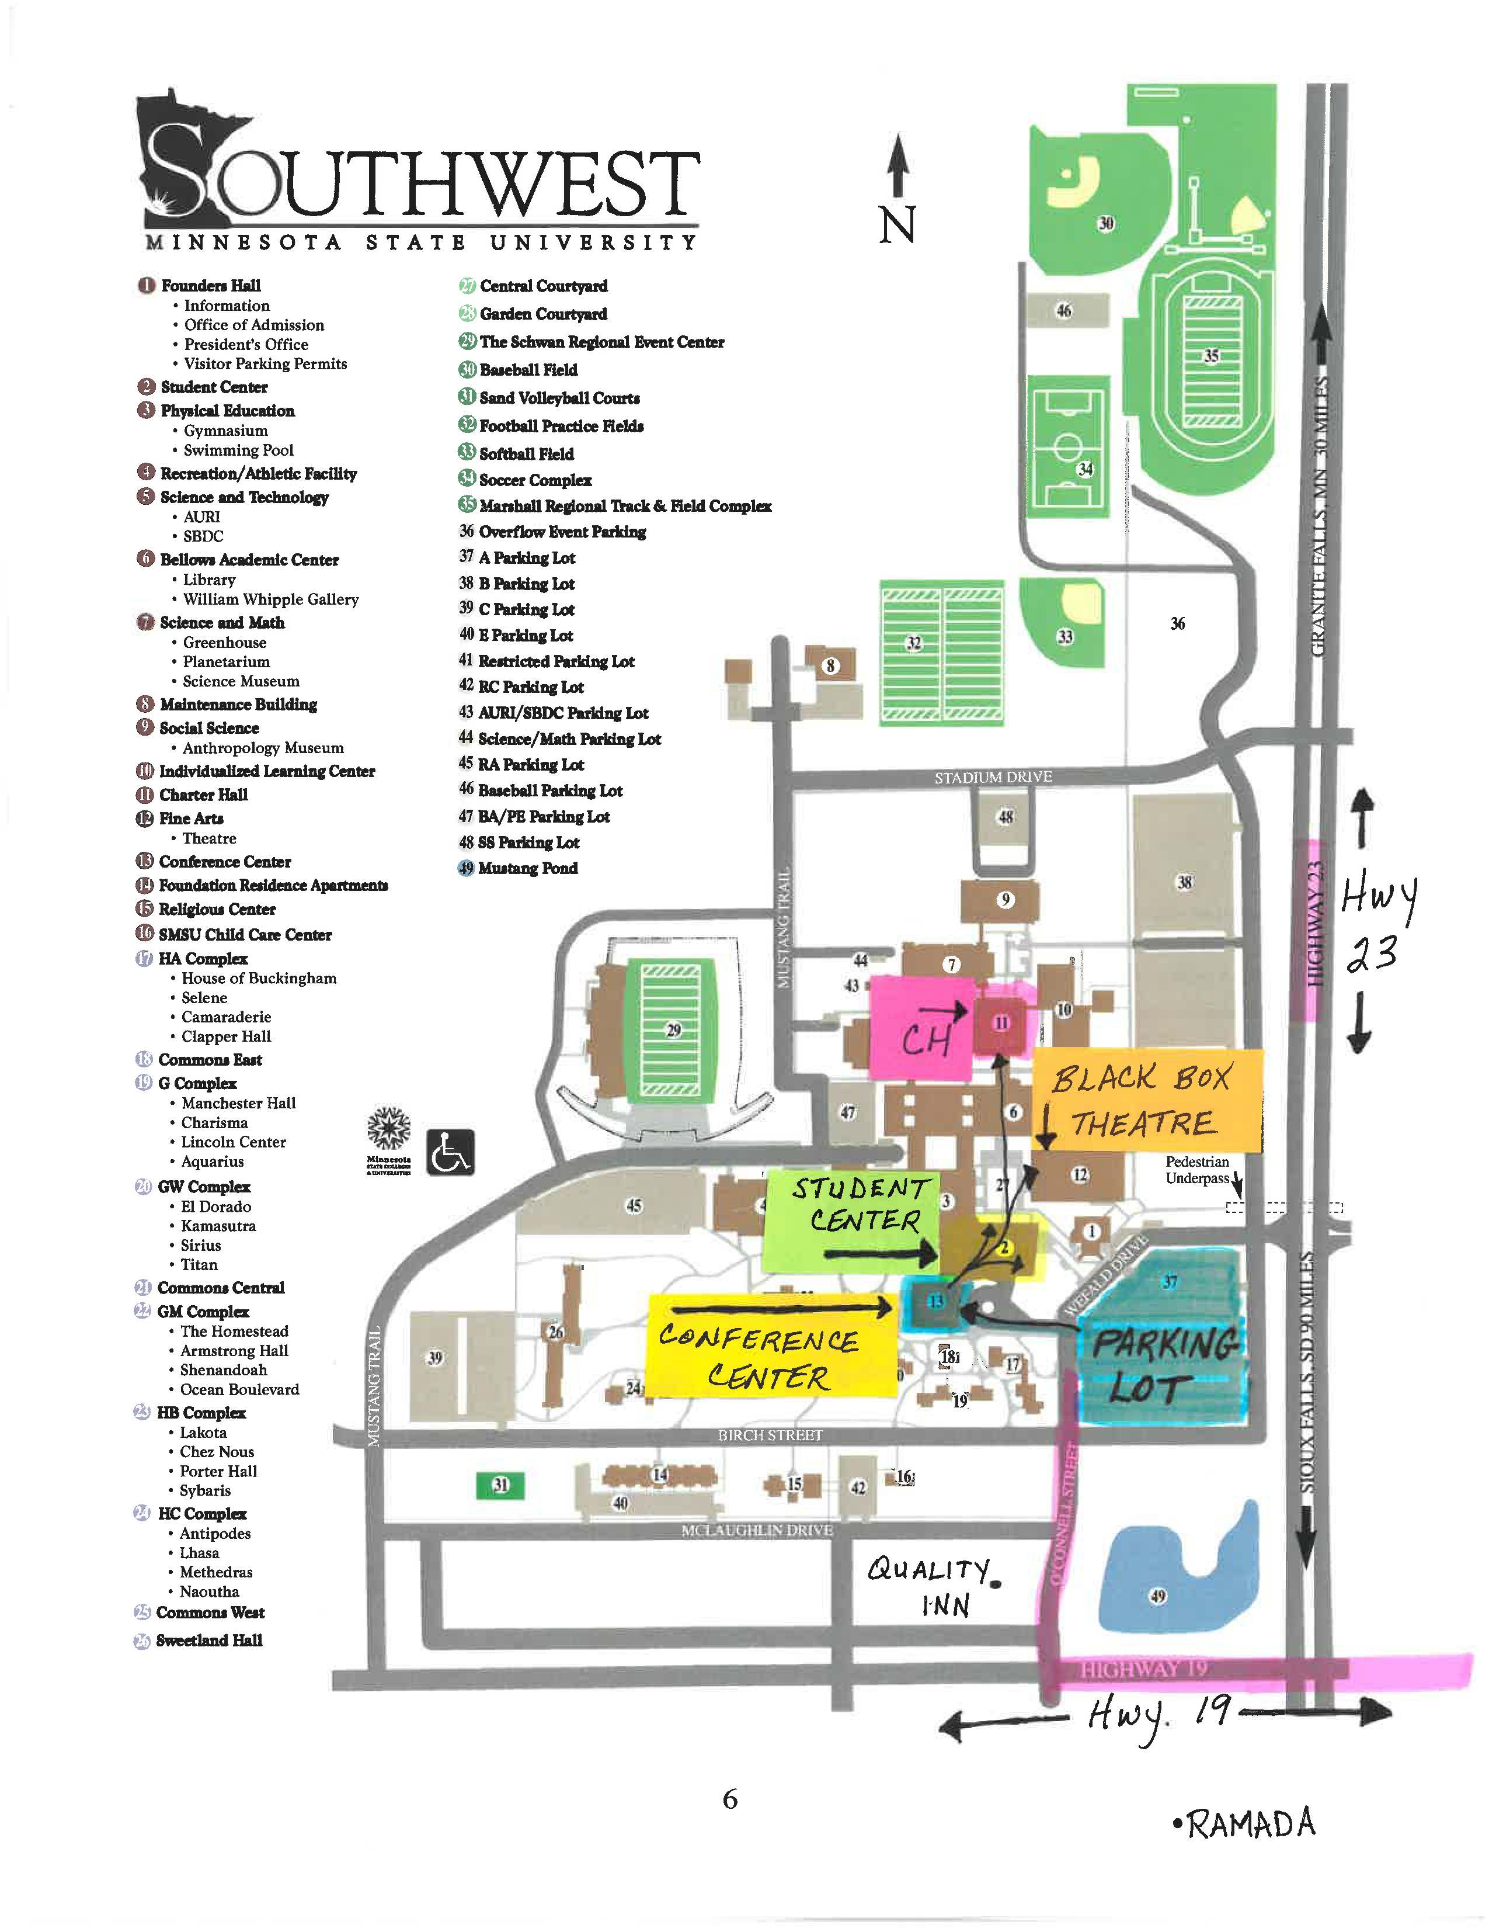
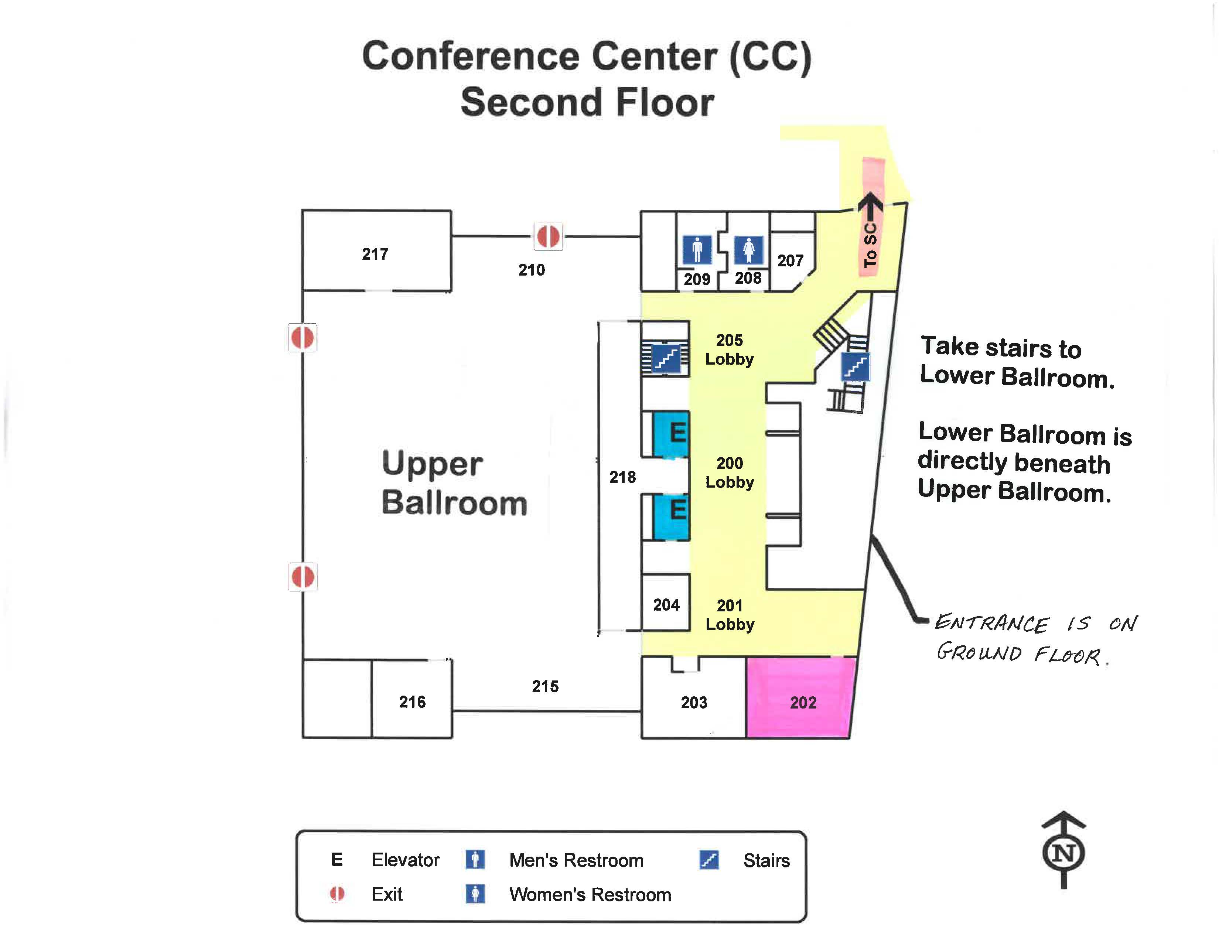

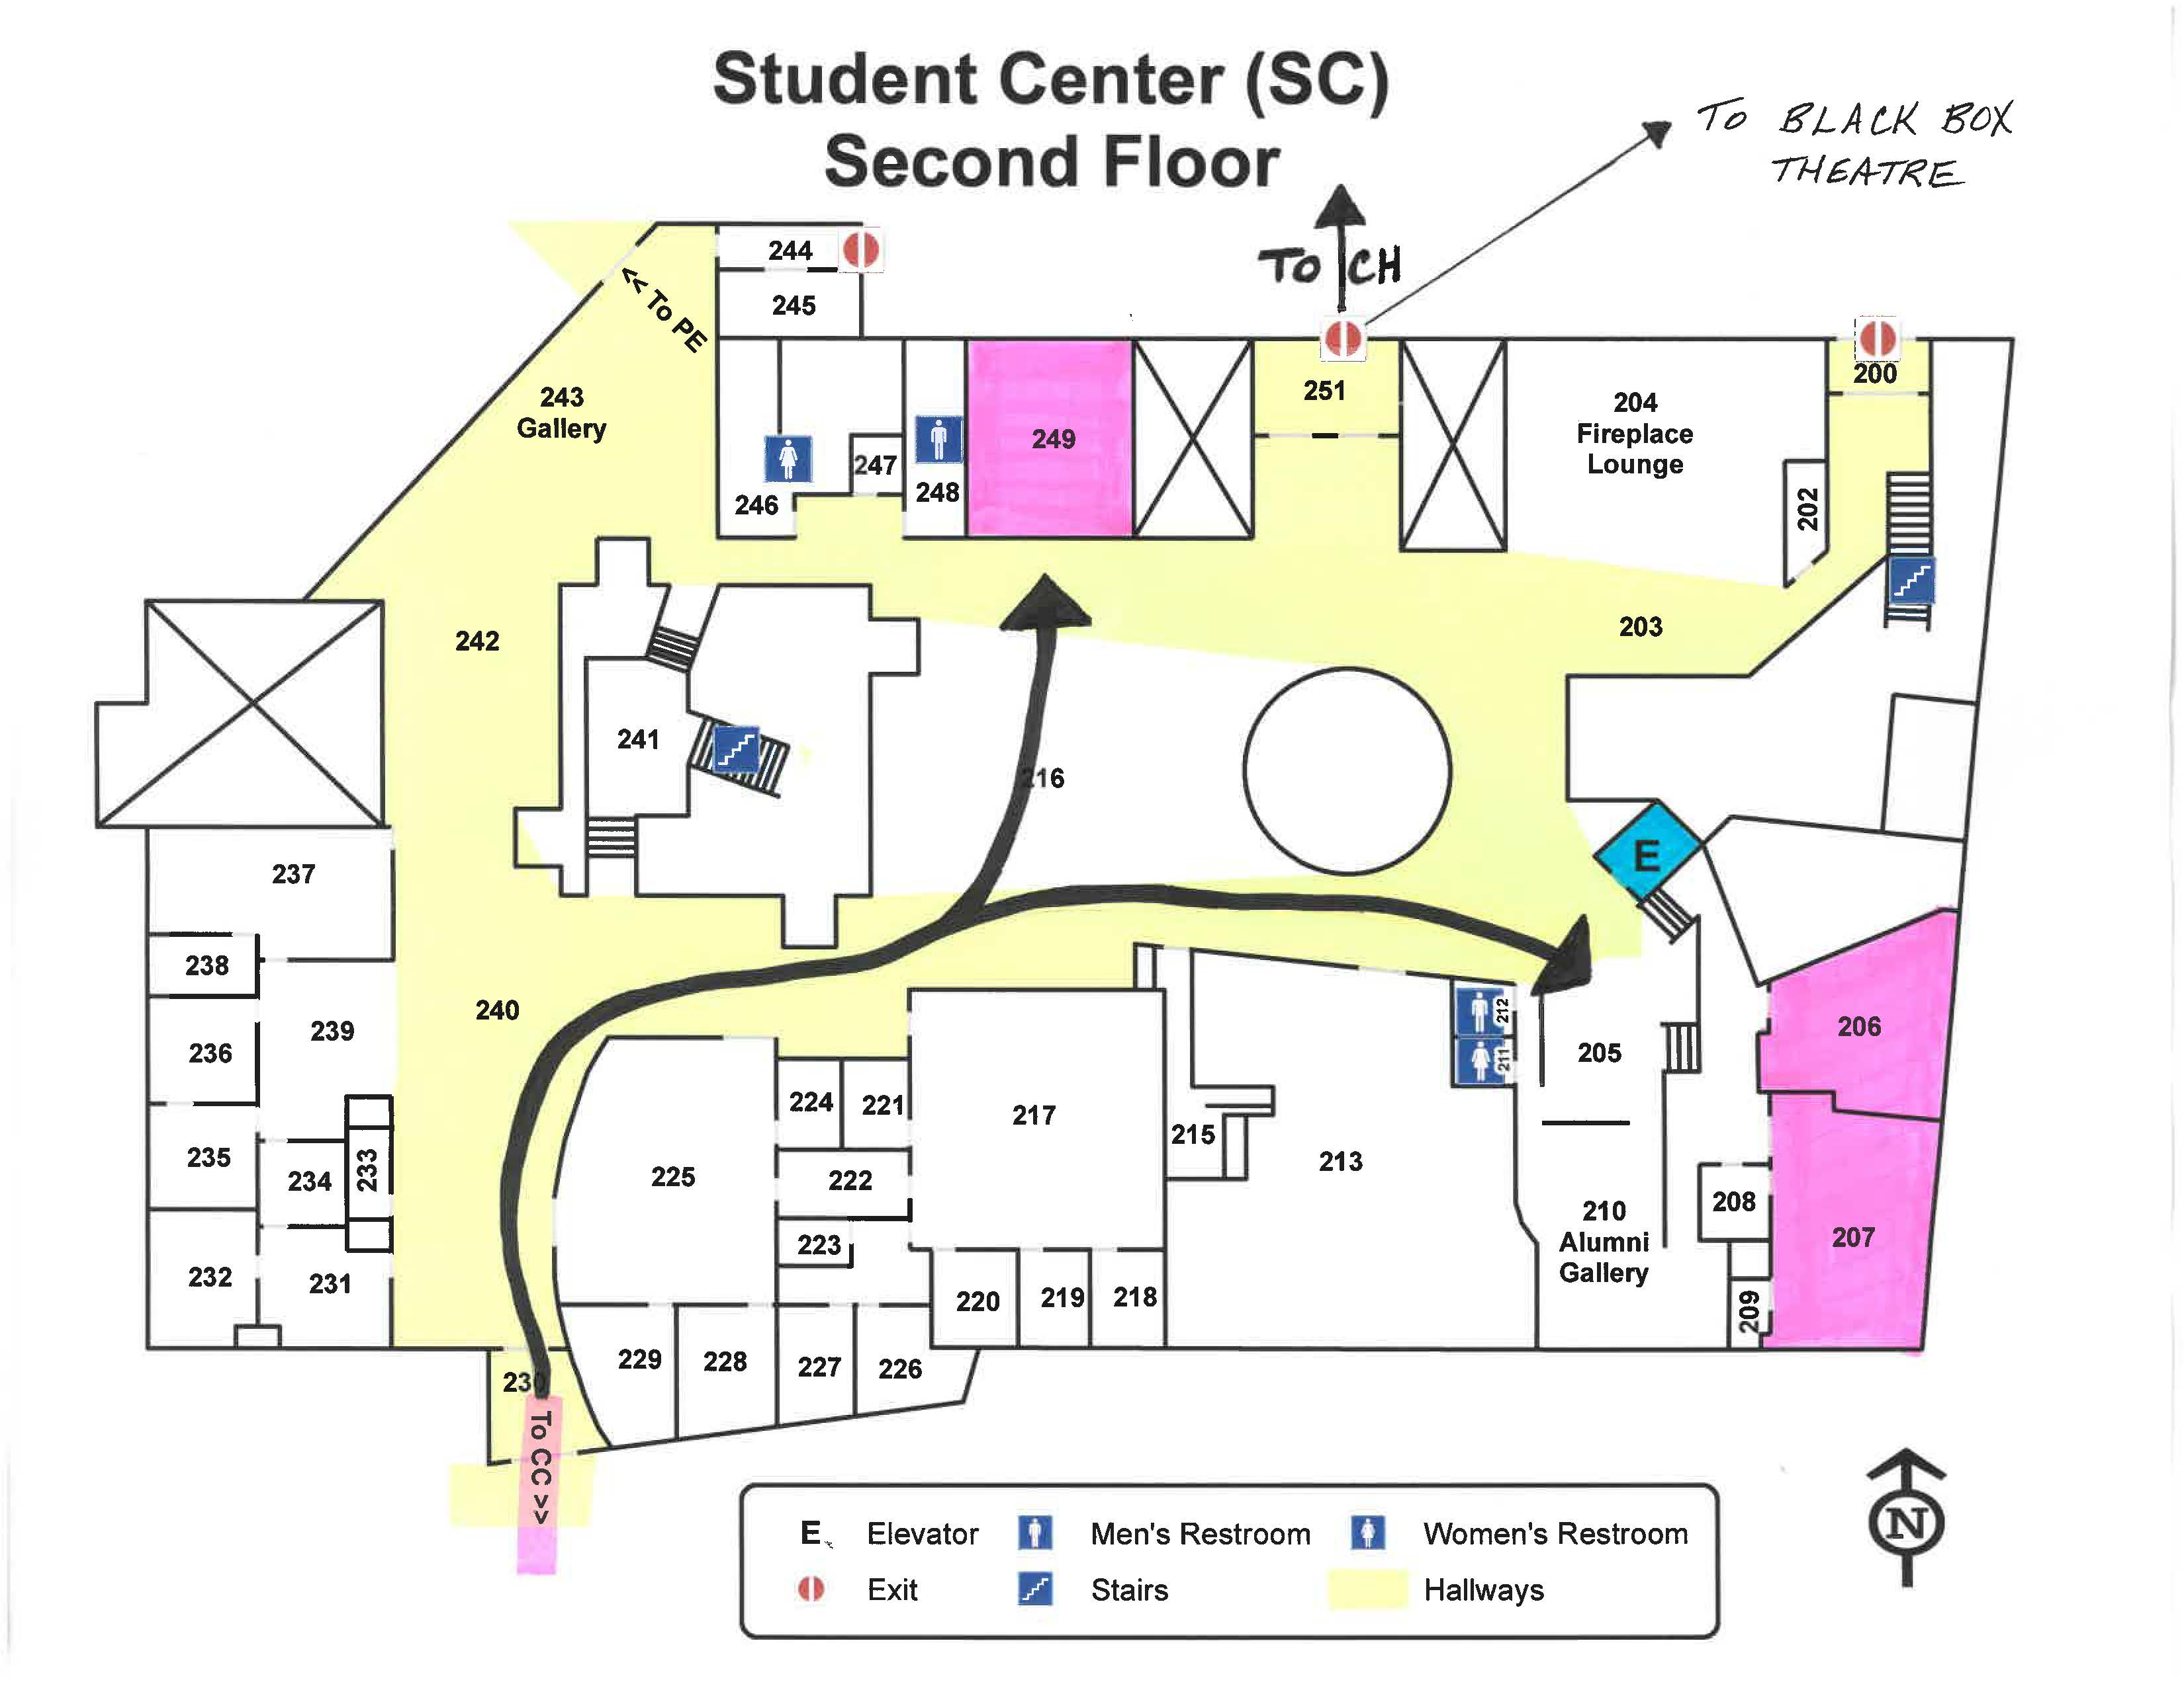

Friday, March 31, 9:00 - 10:00 a.m.
TIME | WORKSHOP/EVENT | Introduction and Plenary |  | ROOM
9:00-  10:00 a.m. | Plenary Session | Welcome from Larry Sklaney, Conference Coordinator  Connecting Landscapes through  “Ecopreneurship” and Narrative:  A Call for Sustainable Writing Program Growth  - Teresa Henning  Professor of English at Southwest Minnesota State University, founding Director of the Professional Writing and Communication (PWC) major  - Amanda Bemer  Associate Professor of English at Southwest Minnesota State University, Director of Academic and Professional Writing  - Kevin Danielson  Senior undergraduate at Southwest Minnesota State University majoring in Professional Writing and Communication  Amanda Bemer and Teresa Henning will make the optimistic pitch that even in times of austerity and political uncertainty, administrating an undergraduate professional writing major can be rewarding if one is willing to be an “ecopreneur” committed “to making a living while supporting the health of others through selective use of “economic and sustainable practices” (Ivanko, 2008). Common, context-sensitive, ecopreneurial strategies include: bartering, rescuing, reusing, exchanging, recycling, sharing, and repurposing (Ivanko, 2008). Using these strategies, the ecopreneur has the potential to connect landscapes, relations, and disciplines in a manner that allows for creativity, diversity, cooperation, and competition.  Bemer and Henning will describe their academic landscape, review theory and strategies related to ecopreneurship, and offer three narratives designed to illustrate how this model of administration connects landscapes. Two narratives demonstrate curricular and disciplinary connections made by professors Bemer and Henning while Kevin Danielson’s narrative offers a student perspective on the types of connections possible when employing ecopreneurial strategies. In the discussion following the plenary, audience members will be invited to consider how they might use ecopreneurial strategies to connect landscapes at their own institutions. |  | Upper Ballroom

Friday, March 31, 10:10 - 11:25 a.m.: Concurrent Sessions A
TIME | WORKSHOP/EVENT | TITLE – Concurrent Sessions A |  | PRESENTER | ROOM
10:10-  11:25 a.m.  Choose your event from these five options. | 1. Roundtable | “Continuing the Conversations: TYCA-Midwest 2017 in Saint Paul” | Brian Lewis, Century College |  | SC 207
 | 2. Workshop | “The Rhetoric of Cool: Multimodalities in the Composition Classroom” |  | Janice Bayer,  Normandale Community College  Meg Hatton,  Normandale Community College | SC 249
 | 3. Panel | “Engaging Discourse Communities”  “Inside, Outside, Upside Down: Teaching about Prisons while Teaching on the Inside: Integrating Place and Ideas of Place” |  | Marlene Tovar, Florida International University  Pat Darling,  Metropolitan State University, Century College, and Augsburg College | CC 202
 | 4. Workshop | “Creating Space with Autoethnography and Critical Pedagogy Using Citizen by Claudia Rankine” |  | Jan Rieck, Champlin Park High School | SC 206
 | 5. Reading of Creative Writing | “Crossings: Over the Reservation Line”  “Poems in Place” |  | Justin Blessinger,  Dakota State University  John Reinhard,  South Central College | Lower Ballroom

Friday, March 31, 11:30 a.m. - 1:15 p.m.: Keynote I

TIME | WORKSHOP/EVENT | Lunch and Keynote I |  | ROOM
11:30 a.m.-  1:15 p.m. | Lunch | Lunch, for those who have requested this meal in advance.  Welcome from Marshall Mayor Bob Byrnes  President Connie Gores,  Southwest Minnesota State University  (Video Welcome) |  | Upper Ballroom
12:15 a.m.-1:15 p.m. | Keynote I | A Journey Through Educational Landscapes  Muriel Thompson  “Growing up in a small town in South Dakota, I never envisioned a career in education. Most of my classmates were content to graduate from high school, get married, and settle into life in our farming community. I think I was one of four girls in our graduating class who went on to college. So, how did this young girl become the director of one of the National Writing Project sites?  Through a series of timely events, I have been fortunate to journey through several educational landscapes that led me to this amazing position. Sharing my journey should be an incentive for all to be open to the unexpected.”  Muriel Thompson recently retired as the director of the Minnesota Writing Project, which she helped to establish at the University of Minnesota in 1990. At the university she also co-coordinated the College in the Schools Composition program for several years. For over thirty years, she taught language arts at Burnsville High school, where she was actively involved with the district’s curriculum work and staff development programs. |  | Upper Ballroom

Friday, March 31, 1:20 - 2:35 p.m.: Concurrent Sessions B
TIME | WORKSHOP/EVENT | TITLE – Concurrent Sessions B | PRESENTER | ROOM
1:20 – 2:35 p.m. | 1. Workshop | “A Journey Through Educational Landscapes: Workshop” | Muriel Thompson and Stephanie Rollag Yoon,  University of Minnesota,  Twin Cities | Upper Ballroom
 | 2. Panel | “Contemporary Indigenous Literature: Lessons in Challenging Power, Bridging Divides, and Mining for Truths”  “Defiance as a Literary Theme” | Judy Wilson,  Southwest Minnesota State University  Brent Heffron,  Century College | SC 206
Choose your event from these five options. | 3. Panel | “First-Year Writing: Towards a Landscape of Development” | Patrick Bruch, University of Minnesota, Twin Cities  Thomas Reynolds, University of Minnesota, Twin Cities | SC 249
 | 4. Panel | “Feminist Pedagogy: Love, Dialogue, and Creativity in Three Writing Classrooms” | Dan Darling,  Normandale Community College  Tom Maltman, Normandale Community College  Loli Dillon, Normandale Community College | SC 207
 | 5. Special Session: Reading of Creative Writing | “Exploring the Landscape of the Self Through Poetry”  “Crossroads of Memory and Imagination: Poems, Prose, and Process” | James Autio,  Hamline University  Daniel Ruefman,  University of Wisconsin—Stout | Lower Ballroom

Friday, March 31, 2:45 - 4:00 p.m.: Concurrent Sessions C
TIME | WORKSHOP/EVENT | TITLE –Concurrent Sessions C | PRESENTER | ROOM
2:45-  4:00 p.m.  Choose your event from these four options. | 1. Workshop | “Teaching Literature Using Writing” | Richard Jewell, Inver Hills Community College | SC 206
 | 2. Panel | “The Inclusion of ESOL Students in a Mainstream Classroom”  “An Instructor's Approach To Plagiarism” | Beata Pueschner,  Anoka Ramsey Community College  Mary Ellen Daniloff-Merrill, Southwest Minnesota State University | SC 249
 | 3. Panel | “Reducing the Demand: Developmental Writing Initiative UW-Stout”  “Say Something!: Teaching Risk in the Classroom” | Daniel Ruefman,  University of Wisconsin-Stout  Laura McCartan,  Metropolitan State University | CC 202
 | 4. Roundtable | “Practical, Pedagogical, and Professional Transformations in the Concurrent Enrollment English Classroom” | Michael Albright,  Lisa Lucas Hurst, and Eric Doise  Southwest Minnesota State University | SC 207

Friday, March 31, 4:15 - 7:00 p.m.: Happy Hour
4:15 p.m. – 7:00 p.m. | Happy Hour at  Bello Cucina  Everyone welcome. Reservation is under Minnesota Writing and English/Lisa Lucas Hurst.  Self-pay. | Bello Cucina  100 West College Drive  Marshall, MN 56258  We will meet at Bello Cucina. At 4:30 pm, Mayor Bob Byrnes will give us a walking tour of 3 downtown murals and the Lyon County’s History Museum.

Saturday, April 1, 9:00 – 10:00 a.m.: Plenary
TIME | WORKSHOP/EVENT | Plenary |  | ROOM
9:00-  10:00 a.m. | Plenary Session | New Territory:  How Concurrent Enrollment Connects the Landscapes of Secondary and Post-Secondary English  - Adam Lowe (via Skype)  First Executive Director of the National Alliance of Concurrent Enrollment Partnerships (NACEP)  - Pakou Yang  System Director of P-20 and College Readiness for Minnesota State Colleges and Universities  - Lisa Lucas Hurst  Assistant Professor of English and Concurrent Enrollment Program Liaison, Southwest Minnesota State University  The panelists will discuss the shifting landscapes of secondary and post-secondary education which have resulted in a new “territory” of concurrent enrollment, where college courses are offered in high school classrooms, delivered by high school teachers in collaboration with college partners.  As with any new territory, questions abound about concurrent enrollment. Research from numerous states, however, indicates positive impacts--both with regard to student enrollment and persistence in college, and with regard to rigor and reduced need for remediation. Moreover, the collaborative partnerships fostered by concurrent enrollment programs offer values beyond better academic preparation: They serve as bridges toward transition and transformation for students and educators alike. |  | Upper Ballroom

Saturday, April 1, 10:10 - 11:25 a.m.: Concurrent Sessions D
TIME | WORKSHOP/EVENT | TITLE –Concurrent Sessions E | PRESENTER | ROOM
10:10- 11:25 a.m.  Choose your event from these five options. | 1. Panel | “An Introduction to Somali-American Writers for Writing Instructors & Tutors”  “Cultivating Civic-Mindedness in Student Writers” | Cimarron Burt,  Minnesota State University Mankato; Good Counsel Learning Center  Heidi Burns,  Minnesota State University Mankato | SC 249
 | 2. Workshop | “A New Book Author Tackles Writing Historical Fiction, Based on a True Story. Why a New Ax Murder Book Has Thrilled Minnesotans” | Marty Seifert,  author of Sundown at Sunrise | Lower Ballroom
 | 3. Roundtable | “Practical, Pedagogical, and Professional Transformations in the Concurrent Enrollment English Classroom” | Michael Albright,  Lisa Lucas Hurst, and Eric Doise,  Southwest Minnesota State University | CC 202
 | 4. Panel | “Ecology and Composition: A History” | Nicole Ciulla and Evelyn Meisenbacher,  University of Minnesota, Twin Cities | SC 206
 | 5. Special Session: Spoken Word, Poetry Performance | “The College Experience: Readings by the SMSU Access Opportunity Success Program” | Cassie Williams  Wyatt Alber  Leseana Burns  Marvin Mendoza  Alisha Parker  Jocelyn Rupe | Black Box Theater

Saturday, April 1, 11:30 a.m. – 1:15 p.m.: Keynote II

TIME | WORKSHOP/EVENT | Lunch and Keynote II | PRESENTER | ROOM
11:30 a.m. - 1:15 p.m. | Lunch | Lunch, for those who have requested this meal in advance. |  | Upper Ballroom
12:15 -1:15  p.m. |  | Physical, Mental, Emotional Landscapes:  Navigating the World through Stories  Kirstin Cronn-Mills  “Whether it's through reading them or writing them, stories help us shape ourselves and the world around us. In this active conversation (including activities, brief lectures, and Q&A), Kirstin Cronn-Mills will discuss both teaching and writing stories (whether in prose or in poetry) about our physical, mental, and emotional landscapes in order to better connect with students. Given the diversity of our K-12 and college/university students in the state of Minnesota, their stories may be very different from their teachers' stories. Story inclusivity will serve us all much better than story singularity.”  Dr. Kirstin Cronn-Mills has taught various English courses at the college level for almost 25 years and is finishing her eighteenth year at South Central College in North Mankato. She is the author of three novels and three nonfiction books for young adults, several of which have been Minnesota Book Award finalists. Kirstin is also the recipient of the 2009 Minnesota State College Student Association Excellence in Teaching Award and the 2014 Stonewall Award from the American Library Association for her second novel, Beautiful Music for Ugly Children. She grew up in Nebraska, six blocks east of the American West, but has lived in Minnesota for a quarter-century. |  | Upper Ballroom

Saturday, April 1, 1:20 - 2:35 p.m.: Concurrent Sessions E
TIME | WORKSHOP/EVENT | TITLE –Concurrent Sessions F | PRESENTER | ROOM
1:20 – 2:35 p.m. | 1. Workshop | “But What Do Stories Do?" Story as Action in the Classroom and Beyond” | Kirstin Cronn-Mills | Upper Ballroom
 | 2. Panel | “Connecting Landscapes for Teaching Literature: Local, Global, and Metaphorical” | James Zarzana, Steve Linstrom, and Marianne Murphy Zarzana,  Southwest Minnesota State University | SC 207
Choose your event from these six options. | 3. Panel: Social Divides, Moral Geographies, and Challenging Texts | “Productive Discomforts and Boring Rhetorical Analysis Questions”  “A Tale of Two Classes: Teaching Ta-Nehisi Coates”  “The Marshall Plan: Building the Student Global Mind Brick by Brick” | Larry Sklaney,  Century College  Joan Thompson,  Normanale Community College  Gordon Pueschner,  Century College | SC 249
 | 4. Panel | “Using Memoir to Tap Empathy in College Freshmen in the Upper Great Plains”  “The Prairie Eye of Bill Holm and Other SW MN Writers” | Ryan Christiansen,  North Dakota State University  David Pichaske,  Southwest Minnesota State University | SC 206
 | 5. Panel | “Connecting Creative Writing Studies with Rhet/Comp” | Alexander Champoux and Eric Wisz,  University of Minnesota,  Twin Cities | CC 202
 | 6. Special Session | “Teaching with Motionpoems” | Athena Kildegaard,  University of MN, Morris | Lower Ballroom

Saturday, April 1, 2:45 – 4:00 p.m.: Concurrent Sessions F
TIME | WORKSHOP/EVENT | TITLE – Concurrent Sessions G |  | PRESENTER | ROOM
2:45 – 4:00 p.m. | 1. Workshop | “Connecting Students to Their Communities and the Globe Through Social Justice Education: Persepolis by Marjane Satrapi and Friday Night Lights by Buzz Bissinger” | Jana Rieck,  Champlain Park Highschool |  | SC 207
 | 3. Panel | “The Link between Snow White and Syria: Savages, Victims, and Saviors”  “Dialogical Role of Literature in a Global Age” | Jessica Possin,  Minnesota State University-Mankato  Corina Beleaua,  University of Georgia |  | SC 206
Choose your event from these five options | 3. Panel | “Understanding the ACRL's New Framework for Information Literacy: Exploring How the Frames Can Be Integrated into Writing Pedagogy, Professional Development, and Assessment” | Lori Baker, Lisa Lucas Hurst, Michael Albright, and Eric Doise  Southwest Minnesota State University |  | SC 249
 | 4. Panel | “Writing Your Ecology: Where Ecocomposition Meets the Composition Classroom”  “Researching the Community: Place-Based Research Assignments” |  | Zachary Lundgren,  East Carolina University  Danielle Hinrichs,  Metropolitan State University | CC 202
 | 5. Digital Film Screening | Season Premiere of "Poems from The Field"  (a web series using poetry to explore the inner life of rural Minnesotans) |  | Lauren Carlson,  Pioneer Public Television | Lower Ballroom

Saturday, April 1, 4:15 – 7:30 p.m.: MnWE Meeting and Dinner
4:15 p.m. – 5:30 p.m. | MnWE Committee Meeting  New members welcome! | SC 249
6:00 – 7:30 p.m. | Dinner at  Brau Brothers  Everyone welcome!  Reservation is under Minnesota Writing and English/Lisa Lucas Hurst.  Self-Pay. | Brau Brothers  1010 E Southview Dr, Marshall, MN 56258  We will have a tour of the brewery and then dinner in the back room.
s

MnWE 2017 Conference Abstracts

(Use “Find” function if searching this file on a computer.)

Albright, Michael Southwest Minnesota State University
Doise, Eric Southwest Minnesota State University
Lucas Hurst, Lisa Southwest Minnesota State University

Practical, Pedagogical, and Professional Transformations in the Concurrent Enrollment English Classroom
While concurrent enrollment programs entail collaboration between stakeholders in the high school and partnering university, they also demand a series of transformations. For this roundtable, university professors and high school instructors will discuss how pedagogical techniques, professional mindsets, and personal philosophies alter when delivering a college course to a high school population. Dialogue on this subject matter will make visible challenges, rewards, and discoveries that are inherent to concurrent enrollment, while perhaps demonstrating applicability to broader, pervading theories in composition and literature instruction at the university level.

Autio, James D. Hamline University

Exploring the Landscape of the Self Through Poetry
Poet/artist/educator, James D. Autio, discusses his approach to writing poetry, his use of poem-a-day writing groups, and the potential for discovery via accessing the landscape of the self. Over the years, Autio’s poetic style has evolved to include a great deal of chance and random association, a loosening of adherence to the structures and limitations of the English language, and the exciting possibilities of self-discovery. The language is odd. The images are juxtaposed. The resulting disjointed poems are often rich and exciting, yet require readers to overlay their own cognitive landscapes in order to construct meaning.

Bayer, Janice Normandale Community College
Hatton, Meg Normandale Community College

The Rhetoric of Cool: Multimodalities in the Composition Classroom
We will informally share pedagogy, apps, programs, assignments, and experiences. We are not experts—but we spent the summer creating and playing—and are excited about what we will have to share.

Beleaua, Corina University of Georgia

Dialogical Role of Literature in a Global Age
This presentation aims to portray the dialogical potential literature has in creating a supportive platform for the encounter of the self with the other. When discussing literature, one needs to take into consideration various theories of translation and hermeneutics. Using several hermeneutic lenses, such as Ricoeur's, Levinas' and Certeau's, I will show that literature creates an appropriate context for a reconceptualization of the word dialogue.

Blessinger, Justin Dakota State University

Crossings: Over the Reservation Line
The Fort Peck Reservation and McCone County to the south are divided by the Missouri River, which can only be crossed in two places for the span of the 110-mile wide reservation. Many hours before dawn, Kenny Firemoon finds another way between the worlds, to the old Harry's Nite Club, once a popular spot when the reservation was dry, but now only a threadbare bar where the occasional farmer can pause on a long winter night.

Brian Lewis Century College

Continuing the Conversations: TYCA-Midwest 2017 in Saint Paul
The purpose of this session is to provide attendees with information about the upcoming TYCA-Midwest conference in October. We will explain what the conference will offer to faculty and how it "connects the landscape" of this MnWE conference to a brand-new conference later in the year.

Bruch, Patrick University of Minnesota
Reynolds, Thomas University of Minnesota

First-Year Writing: Towards a Landscape of Development
In the interests of displacing correctness as the central priority of writing instructors, panelists will focus on broadening our definitions of student writerly development. Through a discussion of student writing and sample assignments, panelists will offer examples of alternative conceptions of writing and invite the audience into a conversation about the balance between conventional correctness and other kinds of development within local, institutional and other contexts.

Burns, Heidi Minnesota State University Mankato

Cultivating Civic-Mindedness in Student Writers
Cultivating civic-minded students who are engaged, informed, and able to critically analyze the information inundating them is more important than ever. While students are willing to engage in conversations on current and global events, they aren’t typically well informed or confident of their opinions. MSU instructor Heidi Burns uses a semester-long News Summary Activity that incorporates a learning management system and in-class discussions to cultivate the skills of audience awareness, source evaluation, summary, content analysis, and engaged dialogue. This activity teaches students to be informed and pushes them to participate in a world outside of their own immediate landscapes.

Burt, Cimarron Minnesota State University, Mankato; Good Counsel Learning Center

An Introduction to Somali/-American Writers for Writing Instructors & Tutors
Seven and a half percent of the Somali diaspora resides in the United States; of that, approximately 30,000 displaced Somalis reside in Minnesota. Presently, more refugees arrive in Minnesota from Somalia than any other nation. The diaspora continues to expand with the arrival of displaced Somalis from abroad, and the growth of families having already made their home in the United States. In order to better serve students, writing tutors and instructors must be sensitive to the characteristics and experiences of this student demographic, and well versed in best practices, tutoring styles, and pedagogical theories.

Carlson, Lauren Pioneer Public Television

Season Premiere of "Poems from The Field,” Season 2
"Poems from the Field" is a web series from Pioneer Public Television's Digital Studios that uses poetry to explore the creative and spiritual lives of rural Minnesotans. Produced by Lauren Carlson and Directed by Brendan Stermer, the series uses poems as an entry into rich discussion of the inner-life of residents from the Upper Minnesota River Valley, often centering heavily on the prairie landscape—both its seasons and environment. The screening will include a reading of Carlson's original poetry, which is heavily inspired by her life in Dawson, Minnesota, and discussion of how poetry can forge deeper connections between the inner life and the outer landscape.

Champoux, Alexander University of Minnesota
Wisz, Eric University of Minnesota

Connecting Creative Writing Studies with Rhet/Comp
The newly founded Creative Writing Studies Organization proposes a field dedicated to the critical study of "creative writing." In essence, the CWSO is interested in the interrogation of how “creative writing” is taught—what constructs of “good writing” are promoted, in what ways, and to what effect. While the CWSO was founded by scholars who bridge the “Creative Writing” and “Rhet/Comp” fields, there has been early hostility toward the employment of rhet/comp theories or methodologies in CWS. In this presentation, we highlight several contributions that Rhet/Comp can offer the fledgling field.

Christiansen, Ryan North Dakota State University

Using Memoir to Tap Empathy in College Freshmen in the Upper Great Plains
As social media, digital tribalism, partisan reporting, and fake news continue to emerge as drivers of narcissism, prejudice, and hate in public discourse, how can college English composition instructors face up to students who feel their world view and opinions about people unlike themselves are correct, without basis or based on anecdotal evidence? Learn how one professor uses empathy, argumentation, and critique as an antidote, using The Corps of Discovery expedition journals and also Kent Nerburn's memoirs about his experiences with Native Americans on reservations in South Dakota—texts that are relevant to students of the Upper Great Plains.

Ciulla, Nicole University of Minnesota, Twin Cities
Meisenbacher, Evelyn University of Minnesota, Twin Cities

Ecology and Composition: A History
In this presentation, we will trace the history (i.e., the ups and downs) of ecology and composition in the United States through a scholarly literature review. We will then propose some practical implications for an ecological approach to rhetoric and composition in 2017. How do ecological concepts, both place-based and global, figure in to the composition classroom? Where does “ecocomposition” stand today, and is it viable in the present?

Darling, Dan Normandale Community College
Dillon, Loli Normandale Community College
Maltman, Tom Normandale Community College

Feminist Pedagogy: Love, Dialogue, and Creativity in Three Writing Classrooms
This panel will feature the ways teachers of developmental, composition, and creative writing use feminist pedagogy to build rich spaces for learning. Loli Dillon will present on self-love as an unexpected result of writing prompts and kinship love as an intentional community building technique. Dan Darling will present a framework for a semester that puts students in dialogue with one another and the broader community to solve real-world problems. Tom Maltman will present on the empowerment fostered in creative writing workshops through use of feminist praxis.

Darling, Pat Metropolitan State University

Inside, Outside, Upside Down: Teaching about Prisons while Teaching on the Inside: Integrating Place and Ideas of Place
As a teacher with over 20 years (part-time) experience teaching college courses on "the inside" (and 16 as chapel volunteer), this semester is the first time my "prison life" and writing teacher life have come together in a themed course on mass incarceration. While the community college students read and write about The New Jim Crow and prison memoirs, the Oak Park Hts. students study literature. Their Places/Landscapes are drawn together in my imagination and discourse, and we are all enriched by being together in spring semester synchronicity. We also connect with the American landscape known as The Prison Industrial Complex and how this upside down, racially charged system came to be.

Heffron, Brent Century College

Defiance as a Literary Theme
Structuring writing courses around literature can be enhanced by the choice of materials that cohere around a particular theme. For example, I have chosen a number of short novels that emphasize the nature of defiance against an oppressive system. Students have responded positively to this topic, in part because it reflects their own concerns and desires in the current socio-political atmosphere. I would like to share some responses to the works, which include 1984, A Lesson Before Dying, Billy Budd and The Trial among others.

Jewell, Richard MnWE--Minnesota Writing and English

Teaching Literature Using Writing
Robert Scholes’ acclaimed The Rise and Fall of English spoke in 1998 of the decline of literature courses. He suggested reclaiming literature by teaching it not as appreciation or close reading, but rather by a variety of writing-to-literature lessons. I’m in my third semester of doing this, with strong success. My students learn seven formats: personal responses; analyses using literary elements, short and expanded; interpretive literary theses; literary reviews, creative writings, and critical analyses using close reading. In this workshop, participants will practice directions for these assignments, see student samples, and receive a review of Scholes’ book.

Kildegaard, Athena University of Minnesota, Morris

Teaching with Motionpoems
Writing Professor Athena Kildegaard will discuss their work on an NEA-funded project to create lesson plans for undergraduate poetry classes using motionpoems (short poetry films based on contemporary poems produced by MN non-profit Motionpoems, Inc.). Motionpoems spark student interest and engagement, but they’re also tools to promote discussion, reflection, and critical understanding of things like metaphor, tone, translation, rhyme, and more. Kildegaard will discuss lesson plans and approaches for using motionpoems to teach poetry along with ideas for adapting lesson plans to teach other subjects such as composition and ELL.

Lucas-Hurst, Lisa Southwest Minnesota State University
Albright, Michael Southwest Minnesota State University
Doise, Eric Southwest Minnesota State University

Understanding the ACRL's New Framework for Information Literacy: Exploring how the Frames Can Be Integrated into Writing Pedagogy, Professional Development, and Assessment
The Association of College and Research Libraries adopted a new “Framework for Information Literacy in Higher Education” in January, 2016. Moving beyond prescriptive standards, the six “frames” emphasize the dynamic nature of information and how people attain information literacy; instructors, librarians and students can invoke the frames to ensure attainment of college-level inquiry and critical thinking skills. We will explain the framework and lead discussions on how it compares to the WPA Council’s Outcomes Statement for First Year Writing, how it supports metacognitive similarities between the research and writing processes, and how it could be aligned with writing rubrics and assessment.

Lundgren, Zachary East Carolina University

Writing Your Ecology: Where Ecocomposition Meets the Composition Classroom
Many collegiate composition courses begin by asking students to use their writing to reflect; however, this often leads to writing that can be self-obsessed, be untimely intimate, or struggle with the complexity of identity. By incorporating Ecocomposition, an approach to composition that focuses on relationship and emphasizes “place” in writing, composition instructors can help students recognize the importance of place in their own writing and identities. This presentation proposes a major writing assignment that can serve as an introduction to reflective writing, aiding students in writing about the self through relationships and their own local ecologies.

McCartan, Laura Metropolitan State University

Say Something!: Teaching Risk in the Classroom
This presentation will address the concept of teaching risk in the classroom. We all know writing can be mechanically sound but lack compelling content. What's missing? Often, the writing is all very careful, and what's missing is an interesting take on the subject—an idea or even a phrase that the reader can be nourished by. More and more for me it has come down to the concept of taking intellectual risks. Students are afraid to step outside boundaries. How do we teach the concept of intellectual risk? How do we recognize and reward risk taking? This talk will explore those questions.

Pichaske, David Southwest Minnesota State University

The Prairie Eye of Bill Holm and Other SW MN Writers
Writer Bill Holm speaks of a "prairie eye" which he developed growing up near Minneota, Minnesota, an eye he contrasts to the "woods" or "urban" eye. This prairie eye focuses both his view of the world and his writing. This same prairie vision can be found in the work of other writers who grew up here, such as Paul Gruchow, Robert Bly, Leo Dangel, back to Ole Rolvaag. This presentation will define the prairie vision and sample the work of Holm and other writers.

Possin, Jessica Minnesota State University- Mankato

The Link between Snow White and Syria: Savages, Victims, and Saviors
The way we tell stories influences the way we understand the world around us. Makau Mutua, a human rights advocate, argues that the tendency to characterize individuals as savages, victims, and saviors negatively impacts our response to human rights violations. Mutua's metaphor can be applied to literature as a lens to understand how literature affects our understanding of world events. Jessica Possin will present on the relationship between how we categorize fictional characters and how we relate to the world landscape. This approach to literature can be used in a classroom to teach literary criticism and critical reading skills.

Pueschner, Beata Anoka-Ramsey Community College
Daniloff-Merrill, Mary Ellen Southwest Minnesota State University

The Inclusion of ESOL Students in a Mainstream Classroom
An Instructor's Approach Toward Plagiarism
During this panel, we will discuss ESOL students and plagiarism. Specifically, we will explore how ESOL students may interpret plagiarism differently than native speaking students and what consequences they may face for not following academic integrity. We will also share ideas how to effectively handle plagiarism cases in our classrooms, and how to prepare ESOL students to avoid academic dishonesty. The second part of the panel will focus on practical tools that college instructors can utilize to include ELL students into the classroom. In particular, we will discuss the implementation of the pre-, during, and post-classroom strategies that assist this group of students in becoming active participants of the classroom community.

Reinhard, John South Central College

Poems in Place
This will be a reading of original poems that, in various ways, are anchored to landscape. Some landscapes, of course, we carry around inside of ourselves—and the poems offer a map to those landscapes. There are also landscapes that surround us, that inspire and calm and outrage us. As teachers, we work through these places with our students, learning as we go.

Rieck, Jana Champlin Park High School, Anoka-Hennepin School District

Connecting Students to Their Communities and the Globe through Social Justice Education: Persepolis by Marjane Satrapi and Friday Night Lights by Buzz Bissinger
Social justice education connects students to each other and their communities. Knowledge and exposure not only lead to understanding and communities grounded in their locations but also enable students to reach across global distances to develop connections, compassion, and agency. Using critical pedagogy as the foundation, any text can be utilized to discuss the issues of social justice through the implementation of critical literary lenses. The presenter will demonstrate how to contextualize a text and guide students. Lesson plans and classroom materials will be provided to assist educators in how to address issues of institutional oppression with their students.

Rieck, Jana Champlin Park High School

Creating Space with Autoethnography and Critical Pedagogy Using Citizen by Claudia Rankine
Citizen is a multi-genre text that gives readers the tools to discover themselves regarding racism and white privilege. Rankine’s use of her personal experiences as a woman of color allows the reader distance to see and experience, perhaps for the first time, what role race plays in all lives. This presentation will use Citizen to explore autoethnographic study. Classroom materials will be discussed and provided to assist educators in implementing autoethnography using Rankine’s text.

Ruefman, Daniel University of Wisconsin

Reducing the Demand: Developmental Writing Initiative UW-Stout
Over the past ten years, the University of Wisconsin-Stout has observed a steady increase in the demand for non-credit bearing, developmental writing courses (ENGL 090). To address this issue, UW-Extension awarded UW-Stout a $30,000 grant to establish a summer writing “boot camp” for incoming freshmen who were unable to test into ENGL 101. The goal of this project was to enable students to acquire the skills necessary to bypass developmental writing courses and proceed into credit-bearing courses, hopefully improving graduation and retention rates for these students. This presentation will explore this program and discuss its preliminary findings.

Ruefman, Daniel University of Wisconsin

Crossroads of Memory and Imagination: Poems, Prose, and Process
Whether writing poetry or prose, every writer struggles with inspiration from time to time. During this session, Daniel Ruefman will read selected poems and stories created by dredging that sandbar where memories go to be forgotten. He will discuss the true stories that were the catalyst for these works, reveal how imagination breathed new life into those selections, and will discuss the ethical concerns that creative writers face when navigating this process on their own.

Seifert, Marty Author, "Sundown at Sunrise"

A New Book Author Tackles Writing Historical Fiction, Based on a True Story. Why a New Ax Murder Book Has Thrilled Minnesotans.
Presentation by new author Marty Seifert will cover the challenges of researching and writing historical fiction, based on a true story. "Sundown at Sunrise" is Seifert's new book that reached #2 on the Amazon True Crime genre hotlist since its December release. Seifert will discuss the unique process of sorting fact from fiction, sensitivities of descendent families involved in a gruesome ax murder from 100 years ago, and interesting details of blending in rural Minnesota history with true crime. This presentation includes a free curriculum worksheet that includes comprehension, vocabulary and critical thinking sections.

Sklaney, Larry Century College

Pueschner, Gordon Century College
Thompson, Joan Normandale Community College

Social Divides, Moral Geographies, and Challenging Texts
How can we encourage civility and civic discourse in our Composition classrooms when working with texts that may elicit strong responses? In “Productive Discomforts and Boring Rhetorical Analysis Questions,” Larry Sklaney suggests how students can approach A Good Time for the Truth: Race in Minnesota as a community of writing learners and put more personal responses in constructive dialogue with the authors and each other. Joan Thompson's presentation "A Tale of Two Classes: Teaching Ta-Nehisi Coates" looks at building context, encouraging active discussions, addressing classroom issues, and designing an assignment for students who might not be ready to respond to Coates' ideas. Gordon Pueschner discusses using global issues and historical events to help students figure out where they stand on lesser known issues and to evolve their global frame of mind in “The Marshall Plan: Building the Student Global Mind Brick by Brick.”
Tovar, Marlene Florida International University

Engaging Discourse Communities
For my presentation, I will discuss some initial results of a “pilot” effort I am planning to execute in my first-year writing class. In this activity, students will list the discourse communities they belong to, with an emphasis on their ethnic and geographical membership. They will engage with divergent perspectives by attending to the intersections and conflicts within their own discourse communities. With my presentation, I hope to contribute new pedagogical insights about how to effectively engage students with divergent perspectives.

Williams, Cassie Southwest Minnesota State University

The College Experience: Readings by the SMSU Access Opportunity Success Program
SMSU Access Opportunity Success program will share readings about culture, identity, and obstacles endured while in pursuit of obtaining a higher education. Access Opportunity Success is a retention program that helps first-generation, Pell grant recipients, and students of color develop the academic skills and personal development necessary to successfully navigate through college.

Wilson, Judy Southwest Minnesota State University

Contemporary Indigenous Literature: Lessons in Challenging Power, Bridging Divides, and
Mining for Truths
There are voices that swim upstream, against the current of the dominant and dominating culture. Bolstering such voices results in insight and connections that would otherwise be drowned out by the flood of mainstream writers. Contemporary Indigenous literature is teeming with voices that generate insight and establish cultural connections while challenging the status quo.

Zarzana, James Southwest Minnesota State University
Linstrom, Steve Southwest Minnesota State University
Marianne Murphy Zarzana Southwest Minnesota State University

Connecting Landscapes for Teaching Literature: Local, Global, and Metaphorical
SMSU Professor Steve Linstrom and I will co-present under this heading. Part I, “Local” will speak of local landscapes to teach literature, using regional writers as our basis. Included will be information on immigrant and Native American voices. Part II, “Global” will speak of global landscapes using examples of world writers, such as Alan Paton writing of South Africa, whose work connects with Minnesota students. Part III, “Metaphorical” will discuss writers who create imaginative landscapes, such as dystopian landscapes, that resonate with today’s times and our students. 1984 is an example of this kind of work.

