Minnesota State Colleges & Universities |  |  |  | Minnesota’s Private Colleges
www.mnwe.org

MnWE

Minnesota Writing and English
Conference Program
Sources of Engagement

March 26 - 27, 2015

Inver Hills Community College,
Inver Grove Heights, MN

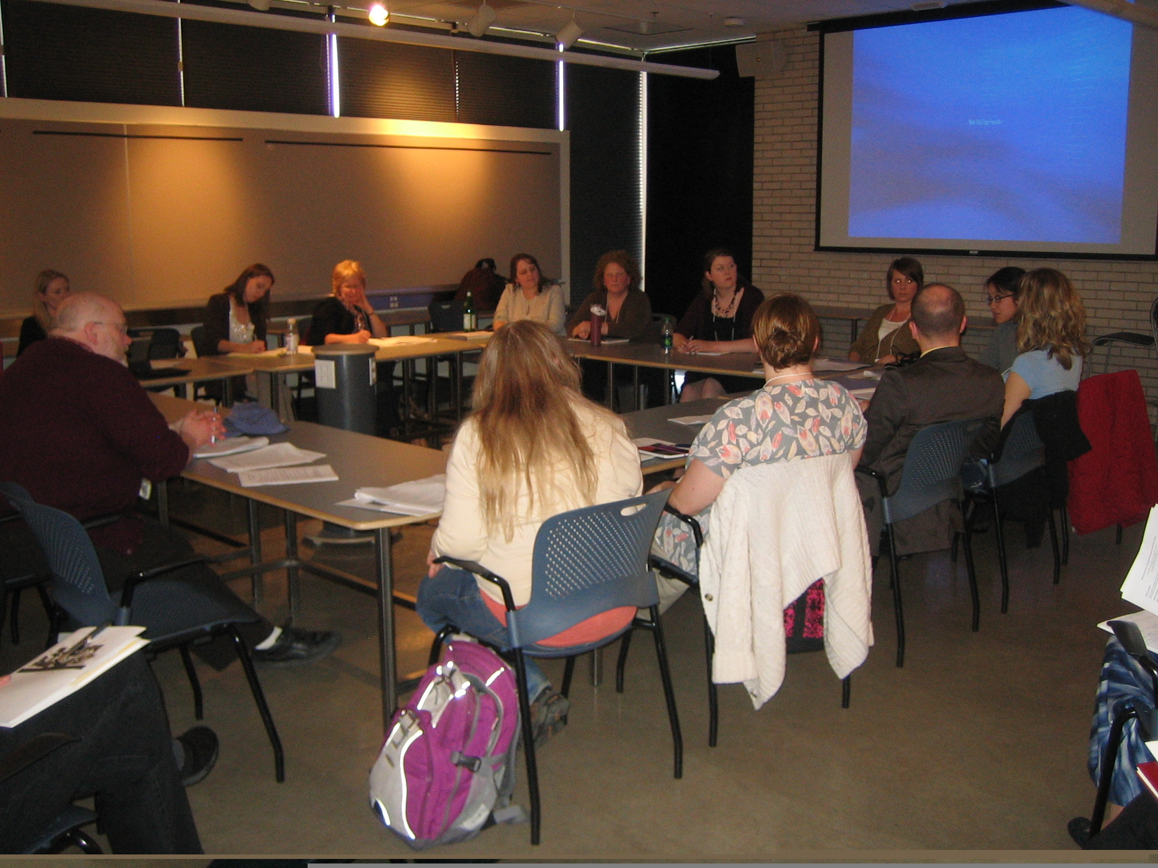

MnWE would like to express its thanks to Inver Hills Community College for its generous donation of conference space, the University of Minnesota Department of Writing Studies for regular donation of meeting space, and the Minnesota State Colleges and Universities (MnSCU) for use of its Lyris Listserv program for the MnWE Newsletter.

MnWE Primary Coordinators
Richard Jewell | General Coordinator | Richard@jewell.net | (612) 870-7024
Larry Sklaney | Conference Coordinator | larry.sklaney@century.edu | (651) 747-4006
Danielle Hinrichs | Program Coordinator | danielle.hinrichs@metrostate.edu | (651) 999-5960
Gordon Pueschner | Creative Coordinator | gordon.pueschner@century.edu | (651) 686-4468

MnWE Committee
This first list contains MnWE Committee members who attend meetings regularly. Anyone may join the Committee who is willing to serve as a volunteer in a significant capacity. Often (but not always) this service includes attending most of the MnWE Committee meetings. If you're interested, let us know, or join us for our meeting at the end of the conference!
David Beard, University of Minnesota-Duluth, dbeard@d.umn.edu
Kirsti Cole, Minnesota State University-Mankato, kirsti.cole@mnsu.edu
Anthony Collins, Inver Hills Community College, acollin@inverhills.edu
Julie Daniels, Century College, julie.daniels@century.edu
Mary Ellen Daniloff-Merrill, Southwest Minnesota State University, mary.daniloff-merrill@smsu.edu
Pat Darling, Metropolitan State University, patricia.darling@metrostate.edu
Anna Davis, Hennepin Technical College, anna.davis@hennepintech.edu
Melissa Giefer, Winona State University, mgiefer@winona.edu
Kate Green, North Hennepin Community College, kate.green@nhcc.edu
K.C. (Kenneth) Hanson, Minn. State Comm. and Tech. College, k.c.hanson@gmail.com
Danielle Hinrichs, Metropolitan State University, danielle.hinrichs@metrostate.edu
Richard Jewell, Inver Hills Community College, Richard@jewell.net
Yanmei Jiang, Century College, ymjiang2008@yahoo.com
Darryl Johnson, Anoka Technical College, daugustj@gmail.com
Trent Kays, University of Minnesota-Twin Cities, trent@trentmkays.com
Amy Kubista, Walden University, amy.kubista@waldenu.edu
Jenna Kulasiewicz, Chippewa Valley Community College, jkulasiewicz1@cvtc.edu
Brian Lewis, Century College, brian.lewis@century.edu
Robyn Madson, Forest Lake Area Schools, rmadson@flaschools.org
Anthony Miller, North Hennepin Community College, anthony.miller@nhcc.edu
Lynda Milne, MnSCU Faculty Development, Lynda.Milne@so.mnscu.edu
Tamar Neumann, Inver Hills Community College, tamar.neumann@gmail.com
David Page, Inver Hills Community College, dpage2@inverhills.edu
Beata Pueschner, Anoka Ramsey College, beata.pueschner@anokaramsey.edu
Gordon Pueschner, Century College, gordon.pueschner@century.edu
Ken Risdon, University of Minnesota-Duluth, krisdon@d.umn.edu
Donald Ross, University of Minnesota-Twin Cities, rossj001@umn.edu
Larry Sklaney, Century College, larry.sklaney@century.edu
Linda Tetzlaff, Normandale Community College, linda.tetzlaff@normandale.edu
Joan Thompson, Normandale Community College, joan.thompson@normandale.edu
Margaret Trott, Winona State University, mtrott@winona.edu
Rex Veeder, St. Cloud State University, rlveeder@stcloudstate.edu
Matt Williams, Inver Hills Community College, mwillia@inverhills.edu

Contact Representatives
This second list contains representatives of MnWE at their schools, who pass MnWE communications on to their departments and other interested members. If you would like to serve as a representative of MnWE for your department and no one else is doing so, please let us know!
Brian Baumgart, North Hennepin Community College, brian.baumgart@nhcc.edu
Laura Benda, Institute of Production and Recording, lbenda@ipr.edu
Ana Davis, Hennepin Technical College, ana.davis@hennepintech.edu
Lee-Ann Kastman Breuch, University of Minnesota, lkbreuch@umn.edu
Kristin Buck, Rochester Community and Technical College, Kristin.Buck@rctc.edu
Kay Dailey, University of Wisconsin-La Crosse, dailey.kath@uwlax.edu
Brandy Hoffmann, Central Lakes College, bhoffma2@d.umn.edu
Ben Kiely, North Hennepin Community College, benjamin.kiely@nhcc.edu
Jenna Kulasiewicz, UW-Eau Claire, kulasijj@uwec.edu
Carol Mohrbacher, St. Cloud State University, camohrbacher@stcloudstate.edu
Heidi Newbauer, South Central College, heidi.newbauer@southcentral.edu
Nick Nownes, Inver Hills Community College, nnownes@inverhills.edu
Karsten Piper, Minnesota West Community and Technical College, karsten.piper@mnwest.edu
Tom Reynolds, University of Minnesota-Twin Cities, reyno004@umn.edu
Barbara Rohrich, Cankdeska Cikana Community College, barbara.rohrich@littlehoop.edu
Kelly Sassi, North Dakota State University, kelly.sassi@ndsu.edu
Erika Scheurer, University of St. Thomas, ecscheurer@stthomas.edu
Stacy Siebert, Waukesha County Technical College, ssiebert@wctc.edu
Scott Stankey, Anoka Ramsey Community College, scott.stankey@anokaramsey.edu
Pam Whitfield, Rochester Community and Technical College, pam.whitfield@rctc.edu
Thomas Zelman, College of St. Scholastica, tzelman@css.edu

Are you on the MnWE e-mail listserv? We send emails about events in our MnWE community about once a month. If you have not recently received MnWE Conference and Minnesota English and Writing information, send your e-mail address to Richard Jewell and ask to be added to the listserv (richard@jewell.net). For more information about MnWE, please visit us online at www.MnWE.org

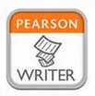

Learn more:
www.pearsonhighered.com

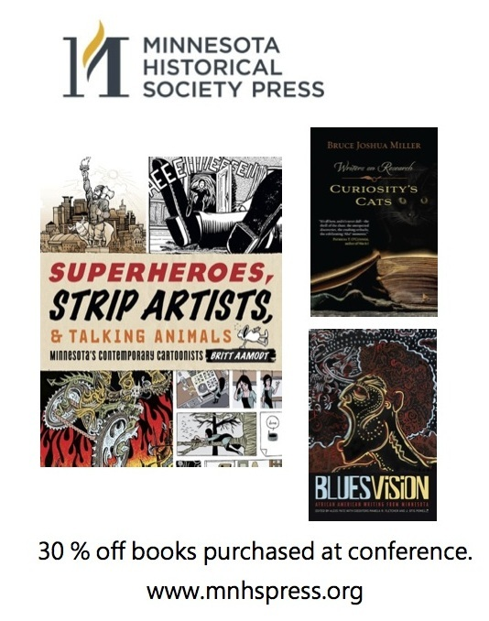

MnWE Conference Sponsor

Cengage Learning

Website:
www.academic.cengage.com

E-Mail:
pat.vauk@cengage.com

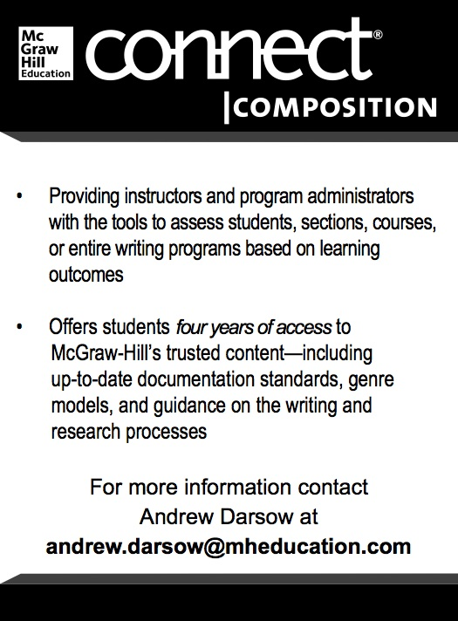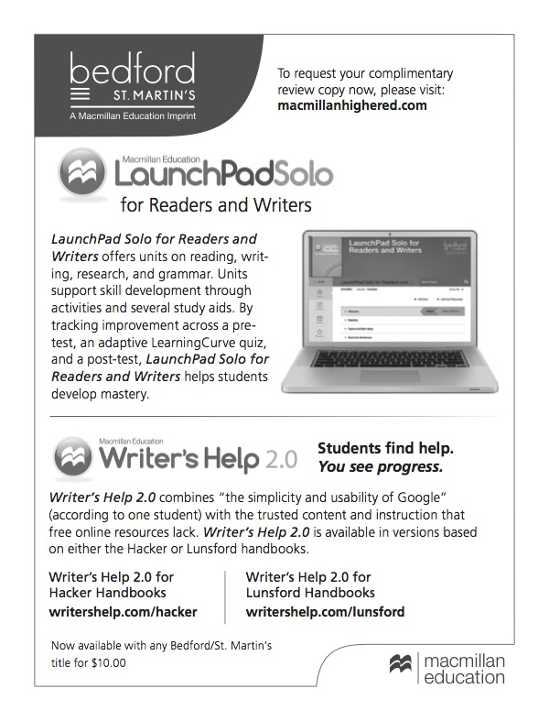
SESSION GUIDELINES FOR PRESENTERS AND CHAIRS (2-15)

Presenters: A Suggested Checklist Guide for the MnWE Conference

Session Presenter Guidelines: The role of the session Presenter is central to the success of the participant experience; these
guidelines help to enhance the session quality for all conference attendees. Thank you.

Presenter preparation before the Conference

_____ Discuss, with your fellow Presenters, the session format, speaking time, placement of question-and-answer portions, and
connections among your topics; if possible, consult with your Session Chair as well.
_____ Advise Conf. organizers in advance if you have any unusual technology requests; all sessions occur in “smart” classrooms.
_____ Inform Conf. organizers by email or telephone if you are unable to attend the conference.

Presenter actions upon arrival at the Conference

_____ Obtain nametag at the Registration Table while determining, in advance of your session, the means to access Tech Support.

Presenter actions at the breakout Session

_____ Arrive at the room 10 or 15 minutes before the session begins, to become familiar with space and equipment.
_____ Verify the format of the session, including order, placement of question-and-answer portions, or any special circumstances.
_____ Become comfortable with fellow Presenters and Session Chair, and clarify your respective roles within the session format.
_____ Limit presentations responsibly within your specified allotted time.
_____ Accept and be aware of the session Chair’s obligation to indicate when the next Presenter’s time has arrived.

Chairs: A Suggested Checklist Guide for the MnWE Conference

Session Chair Guidelines: The role of the Session Chair is instrumental to the success of each session; please use the available
breakout time to guide participants toward the anticipated purposeful goals of the session. Thank you.

Preparation before the Conference
_____ Become familiar with presentations by viewing abstracts prior to the session.
_____ Inform the Registration Desk should a panel Presenter cancel, or should other changes occur.
_____ Contact Presenters prior to the session; possibly request a short bio for introductory purposes.
_____ Consider requesting Presenters’ text and speaking notes beforehand, to better enhance the proceedings.
_____ Prepare a few questions that might stimulate audience participation and interaction.

Actions at the Conference Session

_____ Arrive at the room 10 or 15 minutes before the session begins, to become familiar with space and equipment.
_____ Meet with Presenters shortly before the session to verify session format and confirm personal introductions.
_____ Insure that all Presenters clearly and comfortably agree to format, speaking order and respective roles.
_____ Determine the time for follow-up discussions, which most commonly take place after all presentations are finished.
_____ Notify Presenters regarding planned time limits; please resolve to observe and enforce these limits.

Actions during the Session

_____ Open with introductions; limit your Chair time; promote due Presenter time, audience contributions, questions, and answers.
_____ Manage and enforce time limits professionally, diligently, and firmly with graceful reminders to Presenters.
_____ Facilitate dialogue that promotes respectful and productive interaction; engender varying viewpoints and perspectives among healthy conflict to discover fruitful common ground.
_____ Intervene judiciously to move the session forward, by linking ideas proposed by Presenters and other contributors.
_____ Enable a moderated question-and-answer session; summarize key ideas and proposed follow-up actions.
_____ Thank Presenters and participants, graciously and copiously, when concluding the session.

Aug ed.; his mark, 2-15

Schedule at a Glance

Thursday, March 26:
8:00 a.m. – 2:30 p.m.: Registration
9:00 a.m. – 2:30 p.m.: Publishers’ Displays
---

8:30 – 9:40: Plenary Panel: The State of English and Writing in the Upper Midwest
9:50 – 11:00: Concurrent Sessions A
11:15 – 12:45: Lunch & Thursday Keynote
1:00 – 2:15: Concurrent Sessions B
2:30 – 3:45: Concurrent Sessions C
4:00 – 6:00: Happy Hour at Ruby Tuesday, 9051Buchanon Trail, Inver Grove Heights.
All are welcome. Self pay.

Friday, March 27:
8:00 a.m. – 2:30 p.m.: Registration
9:00 a.m. – 2:30 p.m.: Publishers’ Displays
---
8:30 – 9:30: Plenary Panel: The State of Creative Writing in the Upper Midwest
9:45 – 11:00: Concurrent Sessions D
11:15 – 12:45: Lunch & Friday Keynote
1:00 – 2:15: Concurrent Sessions E
2:30 – 3:45: Concurrent Sessions F
3:50 – 4:50: MnWE Committee Meeting--new members/visitors welcome
5:15 – 6:30: Dinner at Outback Steakhouse, 723 Bishop Ave, Inver Grove Heights.
All are welcome. Self pay.

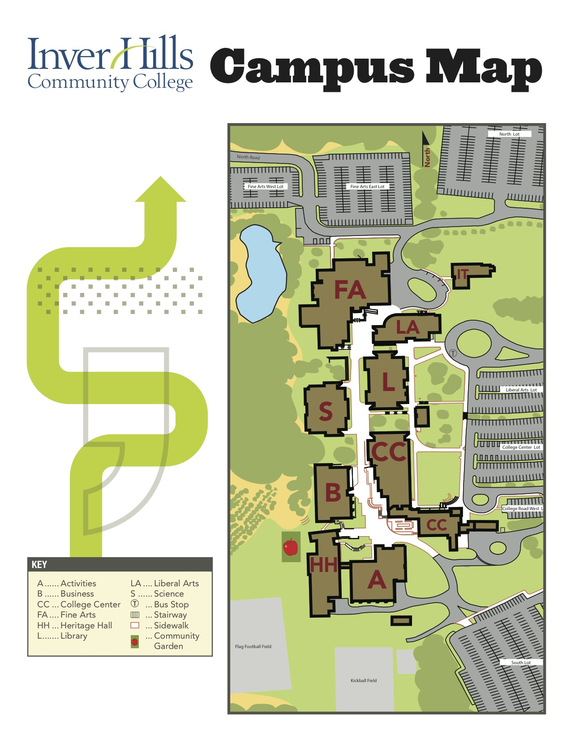

Thursday, March 26, 8:30 - 9:40 a.m.
TIME | WORKSHOP/EVENT | Introduction and Plenary |  | ROOM
8:30-  9:30 a.m. | Plenary Session | Welcome from Larry Sklaney, Conference Coordinator  Presentation from the Loft  The State of English and Writing in the Upper Midwest  - "Engaging Students in Hands-On English Experiences: Service Learning for Writing and Research Classrooms"  Katie Halcrow, Inver Hills Community College  - “Graphically Engaging Students in Graphic Subject Matters”  Michael MacBride, Minnesota State University, Mankato  - “Books are dead, right?!? Myths and Realities of Student Library Use”  Kate Peterson, University of Minnesota, Twin Cities |  | FA Theater

Thursday, March 26, 9:50 - 11:00 a.m.: Concurrent Sessions A
TIME | WORKSHOP/EVENT | TITLE – Concurrent Sessions A |  | PRESENTER | ROOM
9:45-  11:00 a.m.  Choose your event from these seven options. | 1. Workshop | “Workshop on the Teaching of Literature” | Donald Ross  University of Minnesota, Twin Cities  Taiyon Coleman  Minneapolis Community and Technical College |  | FA 194
 | 2. Workshop | “The Gut of Good Teaching: Making Room for the Vital Learning that Rubrics Can’t Capture” |  | Lisa DuRose  Inver Hills Community College  Ellen Lansky  Inver Hills Community College | FA 190
 | 3. Workshop | “Looking Back to Give Forward: Self-Reflection in the Writing Center” |  | Hillary Wentworth  Walden University | LA 131
 | 4. Roundtable | “Supplemental Instruction: Tutors Linked to Classes” |  | Lisa Blauersouth  Hennepin Technical College, Eden Prairie  Kris Bigalk  Normandale Community College  Jackie Reichter  Century College | LA 133
 | 5. Workshop | “Crafting Effective Writing Assignments” |  | Mary Ellen Daniloff-Merrill  Southwest Minnesota State University | LA 132
 | 6. Panel | “Connecting Students to Shakespeare through the Guthrie Theater” |  | Kat Keljik  Educator Coordinator,  Guthrie Theater  Yanmei Jiang, Century College  Natalie Boisen, current student,  Century College  Danielle Dennison, current student,  Century College  Mark Sweigert, current student,  Century College  Megan Wackerfuss,  current student,  Century College | LA 211
 | 7. Special One-Hour Accelerated English Workshop  * This workshop will continue with more speakers after lunch, 1:00-3:00* | “ALP at North Hennepin CC”  “Accelerated Developmental Reading & Writing: Integrated & Non-Integrated Pathways at M State”  “Accelerated Developmental Ed at Lake Superior College” |  | Ben Kiely and Brian Baumgart  North Hennepin Community College  Teresa Beacom, Diana Schirmer, and Diane Stenerson  Minnesota State Community and Technical College  Gretchen Flaherty, Erik Tschekunow, and Keri Rakes  Lake Superior College  Discussion Leader: Joan Thompson  Normandale Community College | LA 210

Thursday, March 26, 11:15 a.m. - 12:45 p.m.: Keynote I

TIME | WORKSHOP/EVENT | Lunch and Keynote I |  | ROOM
11:15 a.m.-  12:45 p.m. | Lunch | Lunch, for those who have requested this meal in advance.  Presentation from Minnesota State Historical Society Press  Presentation from McGraw Hill |  | FA 165
11:45 a.m.-12:45 p.m. | Keynote I | “This Story Could Change Your Life:  Storytelling in (and out) of the Classroom”  - Britt Aamodt  Author of Superheroes, Strip Artists, & Talking Animals: Minnesota’s Contemporary Cartoonists  "Humans are storytelling animals. We may not all be literate, but we're all hardwired for beginnings, middles and ends. As a teacher, you're already a storyteller. But how do you consciously adapt the tools of the storytelling art to the classroom? How do you pull a thread from a novel or short story and weave it into a storytelling moment? And how do we--students and teachers--find our storytelling voices? If we don't tell our stories, who will?" |  | FA 165

Thursday, March 26, 1:00 - 2:15 p.m.: Concurrent Sessions B
TIME | WORKSHOP/EVENT | TITLE – Concurrent Sessions B | PRESENTER | ROOM
1:00 -2:15 p.m.  Choose your event from these five options. | 1. Panel: Engaging Learners in the Writing Classroom | “Engaging Critical Thinking about Learning Styles with Martin Scorsese’s GoodFellas”  (15 min. + discussion)  “Bleacher Creatures: Using Sports to Engage Students in Introductory English Courses”  (15 min. + discussion)  “The Process of Communication: How to Engage Your Classroom with ‘Hot’ and ‘Cold’ Media”  (15 min. + discussion) | William Christopher Brown  University of Minnesota Crookston  Andrew Jones and  Matthew Muilenburg  University of Dubuque  Brooke Boulton  Rainy River Community College | LA 128
 | 2. Workshop | “Concurrent Enrollment: Is This Real College English?” | Robert Stuber and Cindy Ciszewski  Minnesota State College, Southeast Technical | LA 211
 | 3 Panel: Digital Age and the Real World in the Composition Classroom | “Postsecondary Composition Programs for Digital-Age Learners”  (15 min + discussion)  “Composition Pedagogies for the 21st Century: Writing Takes on the Real World”  (15 min + discussion)  “Digital Natives Dig Up the Past: Using Archived Sources for Rhetorical Analysis in Comp/Rhet”  (15 min. + discussion) | J. Corey Fitzgerald  St. Cloud State University  Anne Elstrom Park  Hamline University  Angela Jones  University of Wisconsin, Platteville | FA 165
 | 4. Panel: Engagement and Ownership in the Writing Classroom | “Using Small Contests to Invite Student Engagement in Writing Classrooms”  (25 min. + discussion)  “Talking the Talk: Giving Students Voice to Redefine Success in First-Year Writing”  (25 min. + discussion) | Ashley Clayson  University of Minnesota, Twin Cities  Erica Lange  Saint Cloud State University | Science 135
 | 5. Special Two-Hour Accelerated English Workshop  **This session  lasts two hours  1:00-3:00** | “Express English at Century College”  “The Pleasures and Pitfalls of Teaching Accelerated English: Lessons from the Rochester Pilot”  “Experiences with ALP at Western Technical College”  “Accelerated Learning Curve: How FastTrack Is Changing the Way We Teach” | Cynthia Villegas, Yanmei Jiang, Seong Chan Kang, and Rebecca Johnson  Century College  Pam Whitfield, Mark Schnaedter, and Bonnie Robinson  Rochester Community and Technical College  Stacy Mitchell  Western Technical College  Gaye Pope Carlson and Johan Christopherson  Normandale Community College  Discussion Leader: Joan Thompson  Normandale Community College | LA 127

Thursday, March 26, 2:30 - 3:45 p.m.: Concurrent Sessions C
TIME | WORKSHOP/EVENT | TITLE –Concurrent Sessions C | PRESENTER | ROOM
2:30-  3:45 p.m.  Choose your event from these five options. | 1. Panel | “The Potential for Concurrent Enrollment Partnerships to Serve as Inspiration: Utilizing the Mentoring Model as an Opportunity for Collaboration with High School English Teachers” | Lisa Lucas and  Joel Olson  Southwest Minnesota State University | LA 211
 | 2. Panel | “Line Breaks, Break Dancing, and Breaking Bad: Poetry in the Classroom” | Katharine Rauk  North Hennepin Community College  Brett Elizabeth Jenkins  University of St. Thomas | LA 132
 | 3. Roundtable | “At Your Service: The Shifting World of Adjuncts, Their Resiliency and Survival Skills” | Pat Darling  Century College/ Metropolitan State University  Starletta Poindexter  Century College  Melissa Castillo Reid  Minneapolis Community and Technical College  Anne Winkler-Morey  Metropolitan State University  Heidi Fuhr  Minnesota State University, Mankato | LA 128
 | 4. Panel | “Digital Literacies and Critical Literacies: Working the Tensions to Help First-Year Students Engage” | Thomas Reynolds  University of Minnesota, Twin Cities  Patrick Bruch  University of Minnesota, Twin Cities | LA 133
 | 5. Special One-Hour Developmental Education Legislation Discussion  *This session takes place from 3:10-4:10 p.m.* | “New Legislature Bill To Change Developmental Writing” | Laurel Watt,  Reading Department  Inver Hills Community College | LA 127

Thursday, March 26, 4:00 - 6:00 p.m.: Happy Hour
4:00 p.m. – 6:00 p.m. | Happy Hour at  Ruby Tuesday  9051Buchanon Trail, Inver Grove Heights, MN 55077  651-455-1272  Everyone welcome. Self pay. | Head east on 80th St E toward Blaine Ave E  Turn right onto Cahill Ave  Turn right onto Concord Blvd E  Turn right onto Buchanan Trail. Ruby Tuesday will be on the left.
Friday, March 27, 8:30 - 9:30 a.m.: Plenary
TIME | WORKSHOP/EVENT | Plenary |  | ROOM
8:30-  9:30 a.m. | Plenary Session | Presentation from Pearson  The State of Creative Writing in Minnesota:  Theater and Playwriting  - Julia Brown, The Playwrights’ Center  - Gail Smogard, Metropolitan State University  - Rex Veeder, St. Cloud State University |  | FA Theater

Friday, March 27, 9:45 - 11:00 a.m.: Concurrent Sessions D
TIME | WORKSHOP/EVENT | TITLE –Concurrent Sessions D | PRESENTER | ROOM
9:45- 11:00 a.m.  Choose your event from these five options. | 1. Workshop | “Writing Center Pedagogy in the Composition Classroom” | Julie M. Bach  Hamline University  Gabrielle Rose Simons  St. Mary’s University of Minnesota | FA 190
 | 2. Panel | “Engaging Students with Popular Culture: Indian Detective Fiction, Graphic Novels, Sport Writing, and Adventure Non-Fiction” | Joan Thompson  Normandale Community College  Larry Sklaney  Century College  Gordon Pueschner  Century College | FA 194
 | 3. Panel | “The Multigenre Research Project: How To Successfully Implement and Assess It In Your Own Classroom” | Heidi Burns  Minnesota State University, Mankato  Michael MacBride  Minnesota State University, Mankato | FA 290
 | 4. Workshop | “Using Creativity to Help Students Approach Writing and Organization” | Richard Jewell  Inver Hills Community College  Kathryn Klopfleisch  Inver Hills CC | LA 211
 | 5. Panel | “From Distracted to Discerning: Techniques for Teaching Reading in a Digital Age” | Avesa Rockwell  University of Minnesota, Duluth  Lindsey Jungman  University of Minnesota, Duluth | LA 131

Friday, March 27, 11:15 a.m. – 12:45 p.m.: Keynote II

TIME | WORKSHOP/EVENT | Lunch and Keynote II | PRESENTER | ROOM
11:15- 12:45 p.m. | Lunch | Lunch, for those who have requested this meal in advance.  Presentation from Bedford/St. Martin’s |  | FA 165
11:45-  12:45 p.m. | Keynote II | Uncommon Wisdom:  What Underprepared College Writers (Can) Tell Us  - Linda Lonon Blanton  Professor Emeritus of English,  University of New Orleans  "Before a semester begins, academic courses are set to go, usually designed around content either by faculty assigned to teach them or, in the case of freshman-level writing courses, by department committee. How else can students follow a syllabus and keep on track? And how else can multi-sectioned courses stay calibrated and teachers plan coverage day to day? Yet, experienced teachers know that writing competence does not develop through teaching set material gleaned from others’ notions of what’s interesting or how written English works. By listening 'out of class' to struggling college writers, we can glimpse why many are so very under prepared and unsuccessful. What one year-long conversation tells us is the subject of this presentation." |  | FA 165

Friday, March 27, 1:00 - 2:15 p.m.: Concurrent Sessions E
TIME | WORKSHOP/EVENT | TITLE –Concurrent Sessions E | PRESENTER | ROOM
1:00 – 2:15 p.m.  Choose your event from these five options. | 1. Panel: Social and Political Writing in the Classroom | “Droning for Zones: The Social Aspect of Writing”  (15 min + discussion)  “Engaging the Hostile Audience: Analytical Processes and Political Writing”  (15 min + discussion)  “Comp’s Got Ninety-Nine Problems but Equity Ain’t One: The Challenge of Working Toward Racial Equity in Writing Instruction, Particularly in Minnesota”  (15 min + discussion) | Mohammad Rahman  St. Cloud State University  Leah Heilig and Sarah Stewart  St. Cloud State University  Kathleen DeVore  Minneapolis Community and Technical College | FA 165
 | 2. Panel | “Visual Communication in the Writing Classroom: First Year Writing, Advanced Writing, and Writing Major Courses” | Amy Clark,  Crystal Gibbins, Whitney Walters, and David Beard  University of Minnesota, Duluth | LA 129
 | 3. Panel: Research in the Writing Classroom | “Group Research in an Advanced Writing Class”  (15 min + discussion)  “Individual Research Consultations: Targeting a Student’s Research Needs”  (15 min + discussion)  “Research Papers vs. Researched Writing: Challenging Concepts of Research in Required Writing Courses”  (15 min. + discussion) | Marie Lechelt  Riverland Community College  Mara Wiggins  Southwest Minnesota State University  Danielle Hinrichs  Metropolitan State University | LA 211
 | 4. Panel: Teacher Identity and Perspective in the Classroom | “Qualitative Interviews of the Early Childhood Teachers’ Perspective of Challenges, Resources, and Strategies for Serving English Language Learners”  (15 min + discussion)  “Imposter Syndrome: Responding to Internal and External Threats to Our Identities as Teachers”  (15 min + discussion)  “’They’ Are Watching You: Bigger, Badder Brother Is Back”  (15 min + discussion) | Megan Wisbar  St. Cloud State University  Erin Schaefer  Michigan State University  Kenneth Risdon  University of Minnesota, Duluth | LA 128
 | 5. Panel: Literature and Student Learning | “Literary Soundtracks: Synthesized Learning in the Literature Class”  (15 min + discussion)  “Flipping the Comp and Lit Classroom”  (15 min + discussion)  “Integration of Literature into the Online Creative Writing Classroom”  (15 min + discussion) | Justin Blessinger  Dakota State University  Darcie Rives-East  Augustana College (SD)  Steve Linstrom | LA 131

Friday, March 27, 2:30 – 3:45 p.m.: Concurrent Sessions F
TIME | WORKSHOP/EVENT | TITLE – Concurrent Sessions F |  | PRESENTER | ROOM
2:30 – 3:45 p.m. | 1. Panel | “Making Bank(sy): Using Campus Art Exhibits to Teach Argumentative Writing in FYC” | Sarah Stewart,  Joshua Chase, and  Leah Heilig  St. Cloud State University |  | FA 190
Choose your event from these five options. | 2. Roundtable | “Mentoring for Graduate Students Seeking Jobs” | David Beard  University of Minnesota, Duluth  Richard Jewell  Inver Hills Community College |  | FA 194
 | 3. Panel: The Writing Center | “Instructors, Tutors, and Their Students’ Needs: An Observational Study”  (15 min + discussion)  “Using the Theory of Change in the Writing Center (or Classroom)”  (15 min + discussion)  “Assessing Student Engagement in the Writing Center”  (15 min + discussion) |  | Monica Farrah  Minnesota State University  Lisa Blauersouth  Hennepin Technical College, Eden Prairie  Melanie Cashin  Minnesota State University, Mankato | FA 292
 | 4. Panel: Approaches to Teaching Composition | “Teacher Written Feedback in ESL Composition Classroom: Voices of NNESTs”  (15 min + discussion)  “Engaging Stories: Developing a Campus Literacy Narrative Project in First-Year Writing”  (15 min + discussion)  “Using Figurative Language in the Comp Classroom: On Excess and Scaling Back”  (15 min + discussion) |  | Jun Akiyoshi  Nagasaki Prefectural High School  Jason Tham  University of Minnesota, Twin Cities  Heather Steinmann  North Dakota State University | FA 294
 | 5. Roundtable | “Open Educational Resources in First Year Writing Courses” |  | Trent Kays  University of Minnesota, Twin Cities | FA 296

Friday, March 27, 3:50 – 8:00 p.m.: MnWE Meeting and Dinner
3:50 p.m. – 4:50 p.m. | MnWE Committee Meeting  New members welcome. | FA 196
5:15 – 6:30 p.m. | Dinner at  Outback Steakhouse  723 Bishop Ave  Inver Grove Heights, MN 55076  651-457-7688  Everyone welcome.  Self-Pay. | Head north on Blaine Ave E.  Turn left onto Blackburn Ln.  Turn left onto Bishop Ave. Outback Steakhouse will be on the right.
s

MnWE 2015 Conference Abstracts
(Use “Find” function if searching this file on a computer.)

Akiyoshi, Jun Nagasaki Prefectural High School

Teacher Written Feedback in ESL Composition Classroom: Voices of NNESTs
What generally comes to mind when we hear “teacher engagement” in L2 writing instruction? Not surprisingly, many of us would think of “teacher feedback,” which has played an essential role in L2 writing education. I, as an L2 composition instructor, know a lot about its efficacy theoretically and empirically; however, at the same time, I am doubtful of this pedagogical approach, due to my characteristic, nonnative English speaking teacher (NNEST) with culturally and linguistically non-English background. Inspired by this experience, I collected the voices of some other NNESTs teaching L2 literacy courses in order for prospective NNESTs to raise their awareness on what NNESTs’ teacher feedback is like.

Bach, Julie M. Hamline University
Simons, Gabrielle Rose St. Mary's University of Minnesota

Writing Center Pedagogy in the Composition Classroom: Engaging All Students Through Informed Peer Review
Informed peer review engages students in teaching and learning from each other, resulting in better learning outcomes for everyone. The presenters of this workshop will show how applying writing center pedagogy in the college or high school composition classroom empowers students at any skill level to contribute and receive meaningful, practical insights from peer review. Through hands-on development of course assignments, workshop participants will gain an understanding of writing center theoretical principles and learn concrete strategies to create a classroom environment inclusive of all writers—from the highly skilled to the developing, multilingual, and those with language-based learning disabilities.

Baumgart, Brian (see Kiely) North Hennepin Community College

Beacom, Teresa Minnesota State Community& Technical College
Schirmer, Diana Minnesota State Community & Technical College
Stenerson, Diane Minnesota State Community & Technical College

Accelerated Developmental Reading & Writing: Integrated & Non-Integrated Pathways at M State
Intrigued by data, inspired by others, confronted with the Core Standards, faced with a shrinking budget, and determined to find our way, a group of M State instructors and two deans developed an integrated pathway and a non-integrated pathway for learners at M State to develop the reading and writing skills and proficiency needed to succeed in their college courses. Join us as we share our story and invite attendees to share their stories.

Beard, David (see Clark) University of Minnesota-Duluth

Bigalk, Kris (see Blauersouth) Normandale Community College

Blauersouth, Lisa Hennepin Technical College Eden Prairie
Bigalk, Kris Normandale Community College
Reichter, Jackie Century College

Supplemental Instruction: Tutors Linked to Classes
In this presentation, we have a bunch of different voices from different places talking about the implementation and perpetuation of Supplemental Instruction (SI), from the shaky baby steps starting out to programs that have been doing SI for years. This discussion will allow other tutors and folks who work with tutors to see what the heck our schools are doing, discuss some ideas to try out/steal/think about from outside our programs, and hear about experiences with different programs so we can make our own programs stronger.

Blauersouth, Lisa Hennepin Technical College--Eden Prairie

Using the Theory of Change in the Writing Center (or Classroom)
The Theory of Change is a theory about how people go through the stages of change, and in psychology, it is used to determine how likely a person is to change and where the therapist needs to start with his or her client. In teaching or tutoring, we can, in some respects, call learning a form of change. This paper seeks to start discussion about how we, as instructors and tutors, can utilize the stages of change to help our students from where they are mentally.

Blessinger, Justin Dakota State University

Literary Soundtracks: Synthesized Learning in the Literature Class
Most students are eager to display their taste in music. This assignment requires students to demonstrate comprehension of devices such as theme, setting, character, and critical position by synthesizing their knowledge of a text with that of their chosen lyrics. Students with a particular knowledge of musical theory may eschew lyrics altogether. The final project presents paired text selections with lyrics, analysis, and brief selections of the relevant portion of music. Students demonstrate their learning by defending the perceived overlap between the literary text and their chosen songs. Detailed assignment handout provided.

Boulton, Brooke Rainy River Community College

The Process of Communication: How to Engage Your Classroom with “Hot” and “Cold” Media
This interactive presentation introduces activities that foster confident communication in developmental learners and highlight the roles of instructors in student interest and engagement. When students perceive writing as communication, an expression of their unique voices, they are more receptive to engaging in the process. In Understanding Media, Marshall McLuhan alludes to the invitation of multi-modal participation, and by applying his framework to the writing process, we offer greater opportunities for a more diverse student population to express themselves effectively. In addition, by inviting students to participate in the classroom experience, we establish a community-inspired atmosphere that generates collaborative learning.

Brown, William Christopher University of Minnesota-Crookston

Engaging Critical Thinking about Learning Styles with Martin Scorsese’s GoodFellas
Some first-year composition students resist assignments that do not fit their view of how learning styles work. To counter this tendency to disengage from different ways of learning, I have my students watch the first fifteen minutes of Martin Scorsese’s GoodFellas (1990), which shows how a young boy is enculturated into a life of crime in the mafia. The assignment requires students to analyze and critique a learning style (i.e., visual learning, mentorship, hands-on learning, etc.) represented in the film. My goal with this assignment is to encourage students to engage critically with their preconceived ideas about how to learn.

Bruch, Patrick (see Reynolds) University of Minnesota-Twin Cities

Burns, Heidi Minnesota State University-Mankato
MacBride, Michael Minnesota State University-Mankato

The Multigenre Research Project: How to Successfully Implement and Assess it in Your Own Classroom
Sometimes the most effective teaching techniques involve sleight-of-hand; one such "trick" is the Multigenre Research Project (MGRP). By allowing students to be creative and empowering them to be content generators rather than simply content consumers, students become more engaged in their writing and ultimately produce stronger research-based projects. Minnesota State University-Mankato instructors Heidi Burns and Michael MacBride will present the theories behind the MGRP, provide examples of application in the college classroom through samples of student work, and discuss strategies for successfully implementing your own MGRP.

Carlson, Gaye Normandale Community College
Christopherson, Jonah Normandale Community College

Accelerated Learning Curve: How FastTrack is Changing the Way We Teach
Before we got started doing Accelerated Learning (what we at Normandale call FastTrack), we got lots of great advice and guidance, especially from Peter Adams and colleagues at Baltimore, as well as help from visits to Century College. But there’s nothing quite like teaching in a FastTrack class for experimentation and discovery. At Normandale, our ongoing pilot (we’re now in our second semester) is changing the way we think about teaching in accelerated courses and beyond.

Cashin, Melanie Minnesota State University-Mankato

Assessing Student Engagement in the Writing Center
As part of required program assessment, MSU-Mankato’s Writing Center recently incorporated a post-session survey into each writing appointment. Tutors and writers work together to complete the survey, which is saved electronically and is accessible to future tutors. The presenter will share the survey template, explain the reasoning behind each question, and discuss a sampling of survey responses.

Castillo Reid, Melissa (see Darling) Minneapolis Community and Technical College

Chase, Joshua (see Stewart) St. Cloud State University

Christopherson, Jonah (see Carlson) Normandale Community College

Ciszewski, Cindy (see Stuber) Minnesota State Colleges - Southeast Technical

Clark, Amy University of Minnesota-Duluth
Walters, Whitney University of Minnesota-Duluth
Beard, David University of Minnesota-Duluth

Visual Communication in the Writing Classroom: First Year Writing, Advanced Writing, and Writing Major Courses
Presenters will cover approaches to teaching visual communication in the first year, advanced writing, and writing major classrooms. Topics include utilizing art installations on campus as a provocative point of critical discussion of visual rhetoric in the first year writing classroom, teaching the art of "data visualization" and data journalism to translate peer reviewed research to the public in the advanced writing classroom, and using Berger's "Ways of Seeing" to prompt a discussion of visual culture in a course for Writing Studies majors.

Clayson, Ashley University of Minnesota, Twin Cities

Using Small Contests to Invite Student Engagement in Writing Classrooms
This presenter describes how to use small “contests” in composition classrooms to engage students in daily activities to scaffold learning. This fall, I used two small contests to engage students in activities designed to scaffold learning objectives about document design. In this presentation, I share strategies that helped make these contests successful—providing a small, non-grade-based reward and having students determine contest outcome—and I invite discussion about how the activities could be improved and/or adapted to other learning contexts.

Coleman, Taiyon (see Ross) Minneapolis Community and Technical College

Daniloff-Merrill, Mary Ellen Southwest Minnesota State University

Crafting Effective Writing Assignments
One of the ways we engage students in learning is through crafting effective writing assignments. Instructors need to also recognize the lack of engagement and confusion students experience from poorly crafted assignments. Unfortunately, some instructors were never given guidance in how to develop effective writing assignments. This workshop will address the how-tos of writing assignments at various levels of composition. We will be paying particular attention to purpose and audience with suggestions and methods to help instructors get started. Instructors are encouraged to bring ideas for assignments and assignments which may need revising to the workshop.

Darling, Pat Century College / Metropolitan State University
Poindexter, Starletta Century College
Castillo Reid, Melissa Minneapolis Community and Technical College
Winkler-Morey, Anne Metropolitan State University
Fuhr, Heidi Mankato State University

At Your Service: The Shifting World of Adjuncts, Their Resiliency and Survival Skills
This roundtable will highlight the social, economic, and career issues of English and Writing adjuncts. In spite of their marginalized status, adjuncts have grit, resilience, and survival skills. Roundtable participants will review the past and present situation of adjuncts and will venture into what the next decade will hold for part-time workers in the community colleges, private schools, and state universities. The audience will be invited to contribute to the discussion.

DeVore, Kathleen Minneapolis Community and Technical College

Comp's Got Ninety-Nine Problems but Equity Ain't One: The Challenge of Working Toward Racial Equity in Writing Instruction, Particularly in Minnesota
I will share an overview of my Critical Race Curriculum (Ladson-Billings, Yosso). This work grows out of Critical Legal Studies (Bell, Williams), which posits that because American racism is not the exception but the rule in our settler economy society, a curriculum that ignores this reality simply maintains it. A curriculum that explicitly names systemic racism and helps students to negotiate it engages students of color more effectively and educates students more fully about the intersections of structural racism and College English, which ultimately contributes to greater success for underserved students.

DuRose, Lisa Inver Hills Community College
Lansky, Ellen Inver Hills Community College

The Gut of Good Teaching: Making Room for the Vital Learning that Rubrics Can't Capture
Visceral teaching comes from the inner depths, the “gut.” It includes “gut instincts,” intuition, a sense of things that can’t be measured or quantified—perhaps not even seen at all and yet deeply felt. The vital learning that happens in our classrooms doesn’t always lend itself to quantitative metrics--unless the metric is somewhat subjective, as a "pain scale" tends to be. We aim to explore the ways that the intangibles are essential for us and our students and we invite participants to come prepared with their own visceral accounts of teaching. With all of the emphasis on quantifying and measuring what we do, how do you feed the gut of your teaching? How do you help students recognize and, in some cases, articulate these deeply felt moments? Are they impossible to capture? Please come prepared to engage in a lively discussion about the heart of our craft.

Elstrom Park, Anne Hamline University

Composition Pedagogies for the 21st Century: Writing Takes on the Real World
Stung by post-process claims that there is “nothing to teach” in composition courses, we may be tempted to reframe composition as a site for the learning of forms—brochures, letters, resumes and proposals—teaching students that writing always and only responds to professional “real world” exigencies. However, we fail our students if we don’t engage them in experimenting with the plasticity of language to respond to more varied (and yet still overlapping) contexts, and for purposes that include academic argument, protest, explanation and self-expression.

Farah, Monica Minnesota State University-Mankato

Instructors, Tutors, and Their Students’ Needs: An Observational Study
A classroom teacher sees a student as one part within the context of the whole class; a tutor sees only a student with the context s/he provides. Guiding a student as a classroom instructor and as a tutor provides unique perspectives on the learning process. While each supports the other’s role, there’s often a disconnect, a chicken or the egg scenario: Who’s doing the primary teaching? Does it matter? Are there ways for the instructor and the tutor to increase the awareness of their mutual effort to achieve the goal of a student’s education together?

Fitzgerald, J. Corey St. Cloud State University

Maintaining Aesthetical and Pedagogical Relevance in Postsecondary Composition Programs for Digital-Age Learners
Digital natives have lived with computers and other digital technologies all of their lives. Laptops, notebooks, and smartphones are virtual book bags. Blogs, wikis, and discussion boards riddle the web. Facebook, Skype, and other social media have replaced the need for traditional interactions. Texting exemplifies the immediacy of the times. In the first-year composition classroom, will these same digital technologies allow college students to become better writers? To explore this question further, I will concentrate on the first-year composition classroom and how multi-modal teaching that takes advantage of digital technologies may aid in the accumulation and retention of writing skills.

Flaherty, Gretchen Lake Superior College
Tschekunow, Erik Lake Superior College
Rakes, Keri Lake Superior College

Accelerated Developmental Ed. Workshop
Lake Superior College will be implementing an accelerated, integrated curriculum in developmental reading and writing effective fall ’15. In addition to sharing our rationale and subsequent process for pursuing this significant overhaul, we are interested in further exploring how to maximize the benefits of this new curriculum for our students.

Fuhr, Heidi (see Darling) Minnesota State University-Mankato

Halcrow, Katie Inver Hills Community College

Engaging Students in Hands-On English Experiences: Service Learning for Writing and Research Classrooms
This plenary presentation will briefly touch on what Service-Learning is, research around its efficacy, examples of ways it’s been incorporated into ENG classrooms, and how participants could go about setting it up. Katie Halcrow is the Director of Community-Based Learning at Inver Hills Community College and Dakota County Technical College. She has worked in the field six years, and is constantly energized by the creative connections formed each semester between classrooms and the community.

Heilig, Leah (see Stewart) St. Cloud State University
Stewart, Sarah St. Cloud State University

Engaging the Hostile Audience: Analytical Processes and Political Writing
This presentation outlines the use, discussion, and activities involving readings assigned to two FYC classes: Martin Luther King Jr.’s “Letter from a Birmingham Jail” and an excerpt from Aleksandr Solzhenitsyn’s “The Gulag Archipelago.” The readings facilitated student engagement with reflective writing, textual and contextual analysis, voice modulation, identifying rhetorical strategy, and examining selective emphasis found within arguments directed towards hostile audiences. Using the readings as a framework, students were then assigned to write responses incorporating audience analysis, contextual awareness, and their own reflective composition process.

Hinrichs, Danielle Metropolitan State University

Research Papers vs. Researched Writing: Challenging Concepts of Research in Required Writing Courses
Students (and sometimes instructors) often approach the research paper in terms of quantities, and together, they engage in a quest for more: more sources, more words, more pages. This empty quest can lead to disjointed papers full of misunderstood sources. This presentation will briefly review the history of the research paper and offer ways of framing researched writing assignments that challenge students' preconceptions and lead to more meaningful source engagement.

Jenkins, Brett Elizabeth (see Rauk) University of St. Thomas

Jewell, Richard Inver Hills Community College
Klopfleisch, Kathryn Inver Hills Community College

Using Creativity to Help Students Approach Writing and Organization
This workshop will feature two methods to increase metacognition in composition students. The first method asks students to work individually and in groups to illustrate their own, personal, "real" writing process. The second method features the use of a "technique journal" students create and use to plan papers. The journal helps students understand the various techniques they can use to create and support arguments. Workshop attendees will learn two highly practical, flexible methods they can use in any composition course.

Jones, Angela University of Wisconsin-Platteville

Digital Natives Dig Up the Past: Using Archived Sources for Rhetorical Analysis in Comp/Rhet
Because Millennials tend to have a "preference for experiential learning" (Becker 2012), an assignment designed around the archives is a way to capture students' curiosity. Archival exposure gave students access to tangible items that they held and deciphered—for clues, for intent, for meaning—and analyzed, independently or with the assistance of an archivist. In fact, the initial absence of secondary sources was revealed to be an important step in this student-centered activity, and student ownership of the process was clearly evident in their writing, which revealed a new-old view of making rhetorical arguments out of clues.

Jiang, Yanmei (see Villegas) Century College

Jones, Andrew University of Dubuque
Muilenburg, Matthew University of Dubuque

Bleacher Creatures: Using Sports to Engage Students in Introductory English Courses
The Alliance for Higher Education and Democracy recently noted that 70 percent of higher education leaders polled stated that “athletics are an important component of higher education” (2014). With a growing number of student athletes filling college classrooms, we look at the effects that incorporating reading and writing assignments based around sports had on student engagement in our introductory English courses. Does student engagement increase when texts and assignments are situated in a sports context? Does such material still engage non-athletes through discussion of composition craft and literary merit?

Jungman, Lindsey (see Rockwell) University of Minnesota-Duluth

Kiely, Ben North Hennepin Community College
Baumgart, Brian North Hennepin Community College

ALP Workshop
After a two year pilot of ALP, the English Department at North Hennepin has gone to a full ALP model. All developmental writing sections are paired with a college composition section - 50 sections total and nearly 500 students served. We intend to share our vision, the history of this sweeping change, the curriculum changes, and the bumps in the road to full implementation.

Klopfleisch, Kathryn (see Jewell) Inver Hills Community College

Lange, Erica St. Cloud State University

Talking the Talk: Giving Students Voice to Redefine Success in First-Year Writing
The essay has been the customary indicator of writing ability. Emerging technologies create a need to challenge this standard. I argue that TED Talks present interesting content using a familiar medium. Providing a site of analysis and a genre for composition, TED Talks offer students a way to redefine their preconceived notions about writing within a supportive, collective student composition. Corresponding activities engage more students with the inclusion of multiple learning styles. Essentially, constructing arguments using a multi-modal approach better resembles the type of communication students are likely to produce outside of the classroom—while creating another measure of success, beyond the essay.

Lansky, Ellen (see DuRose) Inver Hills Community College

Lechelt, Marie Riverland Community College

Group Research in an Advanced Writing Class
Students in any writing class often have difficulty with researching and incorporating research into an essay. While there are clear steps and techniques that we can teach them, when it comes down to finding credible sources, mining these sources for appropriate information, integrating this information into their essays, and finding relationships between sources, students struggle. The traditional textbook often seems to jump stages or expect students to go from having source material to a finished essay. In one of my advanced writing courses, I have implemented a group research project. The culmination of the research will be an individual essay.

Lucas, Lisa Southwest Minnesota State University
Olson, Joel St. Francis High School

The Potential for Concurrent Enrollment Partnerships to Serve as Inspiration: Utilizing the Mentoring Model as an Opportunity for Collaboration with High School English Teachers
Concurrent Enrollment (offering college courses in high school settings) is a relatively new but fast-growing field. Many CE programs use a mentoring model, though the relationship between university faculty liaisons and their high school teaching partners can take many forms. In the quest to maintain academic rigor, that relationship can become overly hierarchical. We believe approaching the relationship as an opportunity for collaboration provides an unprecedented opportunity for growth and
inspiration for all involved.

MacBride, Michael Minnesota State University, Mankato

Graphically Engaging Students in Graphic Subject Matters
This plenary presentation will focus on engaging students by using graphic novels in the classroom, and how the images force students to confront material they might have skipped over in a traditional text. Michael MacBride is an adjunct instructor at Minnesota State University, Mankato, where he teaches courses in Literature and the Humanities. Though his PhD is in 19th-century American Literature, he has also taught classes on 9/11 and terrorism, the punk movement, and frequently uses comic books, graphic novels, and comix in his classes.

Mitchell, Stacy Western Technical College

Experiences with ALP at Western Technical College
Western Technical College has been using the ALP format, set by BCCC, to instruct developmental writers. Troubles came at the inception of ALP with advising students into the program and getting them properly informed about the program, but we have managed to advise better every term. My colleagues and I have learned how to promote cohort learning, how to assist the students with using outside resources, and how to instill confidence and skills in the ALP students. With the evidence from student observations and outcomes, ALP is going well.

Muilenburg, Matthew (see Jones) University of Dubuque

Olson, Joel (see Lucas) St. Francis High School

Peterson, Kate University of Minnesota, Twin Cities

Books are dead, right?!? Myths and Realities of Student Library Use
This plenary presentation will explore challenges for students doing research today and what we have learned through a big data project at the University of Minnesota-Twin Cities about supporting student success and retention. Kate Peterson is the Undergraduate Services librarian at the University of Minnesota-Twin Cities. She also works with the Writing Studies department including teaching new students about the Libraries through Orientation and the First Year Writing courses. She previously worked at California State University, Long Beach, St. Cloud State University and Capella University.

Poindexter, Starletta (see Darling) Century College

Pueschner, Gordon (see Thompson) Century College

Rahman, Mohammad St. Cloud State University

Droning for Zones: The Social Aspect of Writing
Being invested in the writing process is probably the most challenging aspect of writing for first-year college students. However, when they bring in their papers to class for guided in-class peer review and engage in dialogue with one another in groups, they get to notice the incongruities in their writing which, according to their own acknowledgement, help them immensely in the writing process. This practice of peer-review and ensuing discussion among the students not only help to develop learner communities in the classroom but also reinforces the social aspect of learning, zone of proximal development (ZPD), a concept Vygotsky initiated.

Rakes, Keri (see Flaherty) Lake Superior College

Rauk, Katharine North Hennepin Community College
Jenkins, Brett Elizabeth University of St. Thomas

Line Breaks, Break Dancing, and Breaking Bad: Poetry in the Classroom
Are your students nervous about deciphering what a poem “means”? Brett Elizabeth Jenkins will share a tried-and-true strategy that helps students read poems confidently and with pleasure. Line breaks are an immediately recognizable sign of verse, but are your students baffled as to what they are for and where they should go? Katharine Rauk will discuss how line breaks in a poem function to introduce tension, control speed, and create a musical score for speech. Attendees will have a chance to share their own experiences and try out some exercises themselves.

Reichter, Jackie (see Blauersouth) Century College

Reynolds, Thomas University of Minnesota-Twin Cities
Bruch, Patrick University of Minnesota-Twin Cities

Digital Literacies and Critical Literacies: Working the Tensions to Help First-Year Students Engage
A central challenge facing writing teachers is how best to navigate tensions between “literacies of the book” and “literacies of the screen.” This panel will offer theoretical and practical resources for responding to this challenge of how best to relate school literacies to digital technologies. Applying an approach of being intentional about how and why digital technologies factor into classroom activities, panelists will present assignments and student work to help audience members reflect on the difficult balancing act of affirming, while also critically challenging, popular digital literacies as a means of helping students develop more traditional, print-based literacies.

Rives-East, Darcie Augustana College (SD)

Flipping the Comp and Lit Classroom
In academia, we often hear about ways to flip the math and science classroom. However, English can also utilize this approach to their advantage and that of their students. This presentation discusses some specific ways teachers of composition and literature can use online tools to move lectures and pre-discussion of assigned writing or texts outside of the classroom so that more class time can be devoted to in-class writing, discussion of student writing, or deeper discussion of literary texts.

Robinson, Bonnie (see Whitfield) RCTC

Rockwell, Avesa University of Minnesota-Duluth
Jungman, Lindsey University of Minnesota-Duluth

From Distracted to Discerning: Techniques for Teaching Reading in a Digital Age
Two first-year-writing instructors will share a study they are currently conducting that compares how 100 students read and absorb print versus online text. By encouraging students to annotate and to reflect on their reading processes, the presenters aim to increase students’ awareness that reading is also a rhetorical act: one that serves different purposes.

Ross, Donald University of Minnesota-Twin Cities
Coleman, Taiyon Minneapolis Community and Technical College

Workshop on the Teaching of Literature
In this workshop, participants will discuss some of the issues and questions confronting literature teachers at two- and four-year colleges, and universities in the twenty-first century. Areas for discussion include, but are not limited to the following:
• Styles of teaching: lecture, recitation, small group, current innovations in the classroom
• Literature courses in the virtual classroom
• Challenges of teaching to mixed student populations
• Examinations: efficacy, delivery -- fact-based, in-class essay questions, etc.
• Impact of "standardization" and "teaching to the test"
• Broad "coverage" (survey), versus sampler courses to teach reading skills
• Number and length of texts
• Multicultural texts
• Value and role of theme-based courses
• Enrollment and ways to attract students
• Student motivation

Schaefer, Erin Michigan State University

Imposter Syndrome: Responding to Internal and External Threats to Our Identities as Teachers
One of the most common problems that I have encountered so far as a beginning instructor in rhetoric and writing is “imposter syndrome,” the perception of being a fraud, unqualified to take on the role of a teacher. This perception can come from our own insecurities about whether we are smart or knowledgeable enough or from our students, who may explicitly challenge our qualifications. One’s race, gender, sexual orientation, ability, and other forms of identity often accentuate the problem of imposter syndrome. In this session, I will explore productive ways of responding to internal and external sources of imposter syndrome.

Schnaedter, Mark (see Whitfield) Rochester Community and Technical College

Schirmer, Diana (see Beacom) Minnesota State Community and Technical College

Simons, Gabrielle Rose (see Bach) St. Mary's University of Minnesota

Sklaney, Larry (see Thompson) Century College

Steinmann, Heather North Dakota State University

Using Figurative Language in the Comps Classroom: On Excess and Scaling Back
Metaphor can be used as a lens though which to see an unknown subject clearly; it can also be used to excess, producing overly “flowery” prose. This presentation will look at examples of metaphor used well and used poorly. Writers will produce a short work using figurative language that complicates the message and then scale the metaphor back to make a usable document.

Stenerson, Diane (see Beacom) Minnesota State Community & Technical College

Stewart, Sarah (see Heilig) St. Cloud State University
Chase, Joshua St. Cloud State University
Heilig, Leah St. Cloud State University

Making Bank(sy): Using Campus Art Exhibits to Teach Argumentative Writing in FYC
This panel describes a collaborative activity developed between three graduate student teachers, used to integrate argumentative writing with community engagement within their respective first-year composition classrooms. The presenters will discuss their experiences with using on-campus art exhibits to facilitate students’ use of evaluation arguments and interaction with visual rhetoric. Presenter one will discuss merging Feldman’s method of art criticism with analytical writing; presenter two will outline the creation of student-dictated criteria, written evaluations, and discuss student response; and presenter three will identify and expand upon the elements of civic discourse and community-focused composition found within the assignment.

Stuber, Robert Minnesota State Colleges - Southeast Technical
Ciszewski, Cindy Minnesota State Colleges - Southeast Technical

Concurrent Enrollment: Is This Real College English?
Smaller, predominantly rural high schools are struggling to meet the expectation of offering college credit to their top performing students. While many high schools can rely on PSEO, others are turning toward Concurrent Enrollment. The presenters, who have each worked with Concurrent for 5 years or more, will introduce the basics of the program and the credentialing challenge. One concern pertaining to the Concurrent Enrollments program is whether these classes can meet college standards. The presenters will also explore constructive ways to make the partnership with the high school faculty more effective.

Tham, Jason University of Minnesota--Twin Cities

Engaging Stories: Developing a Campus Literacy Narrative Project in First-Year Writing
In this presentation, I aim to share The HUMN Project, a semester-long public narrative project designed to provide an opportunity for students to think about their literacy practices and those of others, and to consider issues surrounding literacy acquisition. Students interview people on the University of Minnesota campus (hence H“UMN”) to collect accounts of how individuals remember learning to read and write; the conditions under which they continue reading and composing; and the influences and values that shape their literate practices. Through my presentation, I hope to enlighten teachers and explore ways for advancing practices that complicate literacy values and narrative construction.

Thompson, Joan Normandale Community College
Sklaney, Larry Century College
Pueschner, Gordon Century College

Engaging Students with Popular Culture: Indian Detective Fiction, Graphic Novels, Sport Writing, and Adventure Non-Fiction
Although popular culture usually gets less attention and respect than "Literature" in the classroom, it offers opportunities for engaging our students. Larry Sklaney will discuss using the figure of the Native American detective in fiction to help students understand the concept of cultural work, the messages texts communicate, and why certain messages resonate with audiences. Joan Thompson will discuss using graphic novels in Freshman Composition to deepen students' understanding of visual rhetoric and its role in analytical writing. Gordon Pueschner will discuss using sports writing and popular adventure non-fiction to engage students in the classroom.

Tschekunow, Erik (see Flaherty) Lake Superior College

Villegas, Cynthia Century College
Jiang, Yanmei Century College

Express English at Century College
In this session, we will share the history and the practices of Express English at Century College. For instance, how can students earn eight credits of English? How do we create support network for students and instructors? How does the course work in Composition one and Express work together in terms of scaffolding?

Walters, Whitney (see Clark) University of Minnesota-Duluth

Watt, Laurel Inver Hills Community College

“New Legislature Bill to Change Developmental Writing”
A new bill in the Minnesota Legislature will require MnSCU to create “Supplemental Instruction” for developmental education students, and to “minimize” for-credit developmental courses taught by faculty. This bill may change the way composition—both developmental and college level—is taught and who may teach it. Other departments such as Reading and Math may be even more deeply affected, as well as the entire college curriculum. Join us for the most recent update on what the bill says, what it might do for (to) English, and how it is faring in the Legislature.

Wentworth, Hillary Walden University

Looking Back to Give Forward: Self-Reflection in the Writing Center
In writing center work, it is easy to become bogged down in errors and poor rhetorical choices. A tutor might even start to think of the tutee as entirely different from herself. This chasm is particularly vast in online writing conferences, where the student might just be a name on a page. However, empathy is needed for the tutor-tutee relationship to be successful, no matter the environment. In this workshop, attendees will return to their own formative educational experiences through guided writing exercises. We will then discuss how this reflection can help create a more compassionate feedback voice.

Whitfield, Pam Rochester Community and Technical College
Schnaedter, Mark Rochester Community and Technical College
Robinson, Bonnie Rochester Community and Technical College

The Pleasures and Pitfalls of Teaching Accelerated English: Lessons from the Rochester Pilot
ALP at our college is unique in that we pair our college level writing course with both ENGL 0960 and 0950 (our two levels of developmental writing) successfully. Our panel will address the following aspects of piloting ALP courses:
1. Logistics: how to collaborate with and prepare everyone else on campus
2. Curriculum: developing two dovetailed courses that truly accelerate learning
3. Limits of acceleration: how students in our 0950 and 0960 sections compare
4. Motivation: using materials and concepts that help students see their own potential and develop a growth mindset toward learning
5. Enrollment: issues with retention and pushback against developmental education
Wiggins, Mara Southwest Minnesota State University

Individual Research Consultations: Targeting a Student's Research Needs
When a faculty member decided not to use a textbook for her Writing in Professions course at Southwest Minnesota State University, but to have her students put together several books and articles that would address the types of writing they expected to experience in their individual majors, librarians at SMSU realized that a standard 'one-shot' classroom library instruction session would not be the best way to help each student with their individual needs. The answer: Individual consultations, where both students and librarians found benefit from the experience.

Winkler-Morey, Anne (see Darling) Metropolitan State University

Wisbar, Megan St. Cloud State University

Qualitative Interviews of the Early Childhood Teachers’ Perspective of Challenges, Resources, and Strategies for Serving English Language Learners
The purpose of this study is to uncover a teacher’s perspective of how to improve the education of Early Childhood (EC) English Language Learners (ELL) students by interviewing EC teachers about their experiences, problems, strategies, and recommendations in helping EL students succeed by interviewing up to 10 teachers. Open-ended semi-structured interviews will hopefully uncover their thoughts, feelings, and suggestions on various topics, including, but not limited to: the training, insights, experiences, challenges, classroom management, and resources when teaching and interacting with ELL students at the ECE level.

