  Minnesota State Colleges & Universities |  |  |  |   Minnesota’s Private Colleges
www.mnwe.org

MnWE

Minnesota Writing and English
Conference Program
Locations of Literacy

April 3-4, 2014

Century College,
White Bear Lake, MN
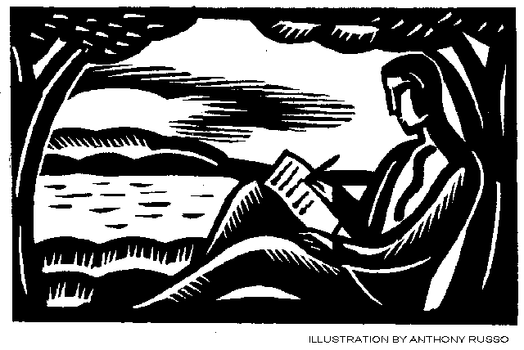

MnWE would like to express its thanks to Century College for its generous donation of conference space and to the University of Minnesota Department of Writing Studies for regular donation of meeting space.

MnWE (Minnesota Writing and English)
Richard Jewell and Larry Sklaney, Coordinators
www.richard.jewell.net - (612) 870-7024
larry.sklaney@century.edu - (651) 747-4006
www.MnWE.org
MnWE Committee:
David Beard, University of Minnesota-Duluth, dbeard@d.umn.edu
Kirsti Cole, Minnesota State University-Mankato, kirsti.cole@mnsu.edu
Marnie Glazier, Inver Hills College, glazierjn@aol.com
Kate Green, North Hennepin Community College, kgreen@nhcc.edu
K.C. Hanson, Minn. State Comm. and Tech. College, k.c.hanso@gmail.com
Danielle Hinrichs, Metropolitan State Univ., danielle.hinrichs@metrostate.edu
Richard Jewell, Inver Hills Community College, richard@jewell.net
Yanmei Jiang, University of Wisconsin, ymjiang2008@yahoo.com
Darryl Johnson, Anoka Technical College, daugustj@gmail.com
Trent Kays, University of Minnesota-TC, trent@trentmkays.com
Jen Kohan, Minnetonka Public Schools, jenkoha@gmail.com
Amy Kubista, Walden University, amy.kubista@waldenu.edu
Brian Lewis, Century Community and Tech. Coll., brian.lewis@century.edu
Christina Lundberg, Hennepin Technical College, cmlundberg@earthlink.net
Anna Martignacco, Hennepin Tech. Coll., anna.martignacco@hennepintech.edu
Anthony Miller, North Hennepin Community College, anthony.miller@nhcc.edu
Lynda Milne, Director, MnSCU Faculty Development, lynda.milne@so.mnscu.edu
Tamar Neumann, Dakota County Technical College, tamar.neumann@gmail.com
Kari Nollendorfs, Rasmussen College, kari.nollendorfs@rasmassen.edu
Laura Pigozzi, University of Minnesota, pigoz002@umn.edu
Gordon Pueschner, Century College, gordon.pueschner@century.edu
Mary Rendahl, University of Minnesota-Twin Cities, renda003@umn.edu
Donald Ross, University of Minnesota-TC, rossj001@umn.edu
Anne Torkelson Shiell, Walden University, anne.shiell@waldenu.edu
Margaret Trott, Winona State University, mtrott@winona.edu
Larry Sklaney, Century Community and Tech. Coll., larry.sklaney@century.edu
Molly Wright Starkweather, Kaplan University, molly.wright@gmail.com
Linda Tetzlaff, Normandale Community College, linda.tetzlaff@normandale.edu
Joan Thompson, Normandale Community College, joan.thompson@normandale.edu
Rex Veeder, St. Cloud State University, rlveeder@stcloudstate.edu
Matt Williams, Inver Hills Community College, mwillia@inverhills.edu
---
Contact Representatives at Their Schools:
Brian Baumgart, North Hennepin Community College brian.baumgart@nhcc.edu
Kris Belden-Adams, Mpls. College of Art and Design, kbeldenadams@mcad.edu
Laura Benda, Institute of Production and Recording, lbenda@ipr.edu
Lee-Ann Kastman Breuch, University of Minnesota-TC, lkbreuch@umn.edu
Kristin Buck, Rochester Comm. and Tech. College, Kristin.Buck@roch.edu
Kay Dailey, University of Wisconsin-La Crosse, dailey.kath@uwlax.edu
Julie Daniels, Century Comm. and Tech. College, julie.daniels@century.edu
Pat Darling, Metropolitan State University, Patricia.Darling@metrostate.edu
Brandy Hoffman, Central Lakes College, bhoffma2@d.umn.edu
Jenna Kulasiewicz, UW-Eau Claire, kulasijj@uwec.edu
Carol Mohrbacher, St. Cloud State University, camohrbacher@stcloudstate.edu
Nick Nownes, Inver Hills Community College, nnownes@inverhills.edu
Karsten Piper, Minn. West Comm. & Tech. Coll., karsten.piper@mnwest.edu
Tom Reynolds, University of Minnesota-TC reyno004@umn.edu
Ken Risdon, University of Minnesota-Duluth, krisdon@d.umn.edu
Barbara Rohrich, Cankdeska Cikana Community College, barbara.rohrich@littlehoop.edu
Kelly Sassi, North Dakota State University, kelly.sassi@ndsu.edu
Erika Scheurer, St. Thomas University, ecscheurer@stthomas.edu
Stacy Siebert, Waukesha County Tech. College, ssiebert@wctc.edu
Scott Stankey, Anoka Ramsey Community College, scott.stankey@anokaramsey.edu
Pam Whitfield, Rochester Comm. and Tech. College, pam.whitfield@rctc.edu

The MnWE Committee meets once every two to four months and is composed of full-time and adjunct instructors and graduate students from Minnesota colleges and universities. Join by e-mailing Richard Jewell or by attending our Friday, 3:50 p.m. meeting in 1331.
Are you on the MnWE e-mail listserv? We send emails about events in our MnWE community about once a month. If you have not recently received MnWE Conference and Minnesota English and Writing information, send your e-mail address to Richard Jewell and ask to be added to the listserv. For more information about MnWE, please visit us online at www.MnWE.org



MnWE Conference Sponsor

Holy Cow! Press

Jim Perlman, Publisher
Duluth, MN

Website: www.holycowpress.org

E-Mail:
holycow@holycowpress.org
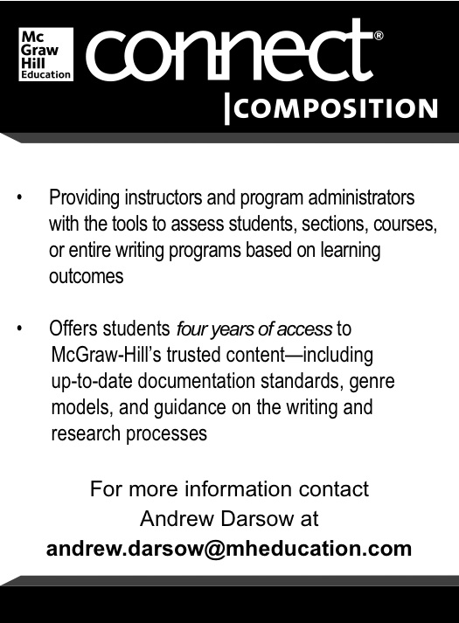

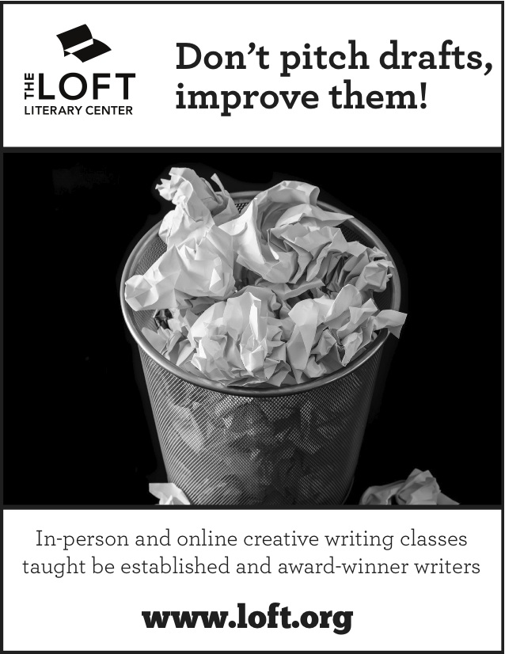
MnWE Conference
Sponsor

W.W. Norton, Inc.
Independent/Employee-Owned Publisher

Contact: Jude Hall
judehall@wwnorton.com

Schedule at a Glance

Thursday, April 3:
8:00 a.m. – 2:30 p.m.: Registration
9:00 a.m. – 2:30 p.m.: Publishers’ Displays
---
8:30 – 9:30: Plenary Panel: The State of English and Writing in the Upper Midwest
9:45 – 11:00: Concurrent Sessions A
11:15 – 12:45: Lunch & Thursday Keynote
1:00 – 2:15: Concurrent Sessions B
2:30 – 3:45: Concurrent Sessions C
2:30 – 4:30: Concurrent Workshops D (2 hours)
4:00 – 6:00: Happy Hour two minutes away at Jethro’s Char-House & Pub, 3140 Century
Ave. N. http://www.jethros-charhouse.com/

Friday, April 4:
8:00 a.m. – 2:30 p.m.: Registration
9:00 a.m. – 2:30 p.m.: Publishers’ Displays
---
8:30 – 9:30: Plenary Panel: The State of Creative Writing in the Upper Midwest
9:45 – 11:00: Concurrent Sessions E
11:15 – 12:45: Lunch & Friday Keynote
1:00 – 2:15: Concurrent Sessions F
2:30 – 3:45: Concurrent Sessions G
2:30 – 4:30: Concurrent Workshops H (2 hours)
3:50 – 4:50: MnWE Committee Meeting--new members/visitors welcome
5:15 – 6:30: Dinner (by reservation at registration desk, self pay) at Washington Square Bar
and Grill in downtown White Bear Lake http://washingtonsquareonline.net.
**Please sign up for dinner at the registration desk by noon.

Thursday, April 3, 8:30 - 9:30 a.m.
TIME | WORKSHOP/EVENT | Introduction and Plenary | PRESENTER | ROOM
8:30-  9:30 a.m. | Plenary Session | Welcome from Larry Sklaney, Conference Coordinator  The State of English and Writing in the Upper Midwest: Domains of Literacy  - "Environmental Literacy"  Phyllis Ballata, Century College  - “Cultural Literacy”  Shannon Gibney, Minneapolis Community and Technical College  - "Information Literacy"  Iris Jastram, Carleton College  - “Civic Literacy”  David Pates, Normandale College |  | Lincoln Mall

Thursday, April 3, 9:45 - 11:00 a.m.: Concurrent Sessions A
TIME | WORKSHOP/EVENT | TITLE – Concurrent Sessions A |  | PRESENTER | ROOM
9:45-  11:00 a.m.  Choose your event from these options. | 1. Individual Presentations (Composition) | “Crossing Boundaries, Unfolding Stories: Medical Humanities, Narratives, and Composition”  (15 min + discussion)  “Dissoi Logoi in the Classroom: Using Sophistic Rhetorical Practices to Develop Research Literacy in First-Year Composition”  (15 min + discussion)  “Environmental Literacy in the Composition Classroom: The Place of the World in Writing”  (15 min + discussion) | Jason Tham  St. Cloud State U  Leah Heilig  St. Cloud State U  Emily Swanson  Anoka Technical College |  | 1331
9:45-  11:00 a.m.  Choose your event from these options. | 2. Roundtable  (Writing Centers) | “Negotiating the Multilingual Universe: How Does Your Writing Center Serve English-Language Learners?”  (50 min + discussion) |  | Jake Mohan, Laura Johnson, and Sophie Keane  Macalester College | 2213
9:45-  11:00 a.m.  Choose your event from these options. | 3. Panel  (Literature) | “Page to Stage: Immersing Shakespeare Students in The Guthrie Theater”  (50 min + discussion) |  | Patrick O’Donnell and Paula Garland  Normandale CC  Louise Chalfant  Guthrie Theater | 2314
9:45-  11:00 a.m.  Choose your event from these options. | 4. Roundtable  (Writing Centers) | “Evaluating Tutor Roles in Academic Literacy”  (50 min + discussion) |  | Nathaniel Taylor and Sarah Johnson  University of Wisconsin, Eau Claire | 2315
 | 5. Panel  (Literature) | “Two-Way Streets: Effective Service Learning Pedagogies”  (50 min + discussion) |  | Mary McCaslin Thompson, Brandy Opse, Kristin Thoennes, Marnie Glazier, and Katie Halcrow  Inver Hills CC | 2311
 | 6. Reading  (Creative Writing) | “Poets and Fiction Writers from MnSCU” |  |  | 2561

Thursday, April 3, 11:15 a.m. - 12:45 p.m.: Keynote I

TIME | WORKSHOP/EVENT | Lunch and Keynote I |  | ROOM
11:15 a.m.-  12:45 p.m. | Lunch | Lunch, for those who have requested this meal in advance.  The Loft Presentation  MacGraw Hill Presentation |  | Lincoln Mall
11:45 a.m.-12:45 p.m. | Keynote I | The Digital Manifesto and Possibilities of Critique  - Tom Reynolds, University of Minnesota-Twin Cities |  | Lincoln Mall

Thursday, April 3, 1:00 - 2:15 p.m.: Concurrent Sessions B
TIME | WORKSHOP/EVENT | TITLE – Concurrent Sessions B | PRESENTER | ROOM
1:00 -2:15 p.m. | 1. Individual Presentations  (Composition) | “The Adjunct’s Added Burden: Recognizing Additional Challenges in Sustaining Locations of Literacy in Adjunct Writing Classrooms”  (15 min. + discussion)  “Writing Across Borders”  (15 min. + discussion)  “This is How We Do It: Creating Community Literacy”  (15 min. + discussion) | Teresa Schneider  St. Cloud State U  and Heidi Newbauer  Minnesota State U, Mankato  Kathy Evertz  Carleton College  Katie Priske  University of Minnesota, Twin Cities | 2271
1:00 -2:15 p.m. | 2. Roundtable  (Writing Centers) | “Navigating Diverse Literacies in the Writing Center”  (50 min. + discussion) | Rachel Grammer and Matt Sharkey-Smith  Walden University | 2273
1:00 -2:15 p.m. | 3. Panel  (Composition) | “Institutions, Instruments, Instruction, and Innovation”  (50 min. + discussion) | Sharon Cogdill, Matt Barton, Jamie Heiman, and Carol Mohrbacher  St. Cloud State U | 2315
 | 4. Individual Presentations  (Teaching with Technology) | “Case Studies as a Site for Developing Literacies: Uncovering Lessons about Rhetorical Appeals and Technical and Environmental Issues Regarding a Contested Landfill Permit in Rural New Mexico”  (15 min + discussion)  “Non-Profit Professional Writing in the Service Learning Classroom: A Collaboration Between St. Thomas, Aeon, the Domestic Abuse Project, the Aliveness Project, and the Legal Rights Center”  (15 min + discussion)  “Low-stakes L2 Writing in the Computer Classroom”  (15 min + discussion) | Rachel Tofteland  University of Minnesota, Twin Cities  Lucia Pawlowski  University of St. Thomas  Daniel G. Tight  University of St. Thomas | 2306
 | 5. Roundtable  (Composition) | “Argumentative Literacy: Arguing in the Classroom”  (50 min. + discussion) | Robyn Madson  (Forrest Lake High School), Elizabeth Haen (Mahtomedi High School), David Borash (Brainerd High School), and Ross Eichele (Blaine High School) | 2314
 | 6. Panel  (Creative Writing) | “To Birth a Mockingbird: Leveling the Playing Field through Imitation in Teaching Creative Writing”  (50 min. + discussion) | Brian Baumgart (North Hennepin CC), Jenny Yang-Cropp (University of South Dakota), and Bronson Lemer (University of Minnesota, Rochester) | 1331
 | 7. Reading  (Creative Writing) | “University of Minnesota Creative Writing Graduate Students”  (50 min. + discussion) |  | 2313

Thursday, April 3, 2:30 - 3:45 p.m.: Concurrent Sessions C

**Please note that you may choose to attend one event from Concurrent Sessions C (one hour and 15 minutes) or one event from Concurrent Workshops D (2 hours) below. Both begin at the same time.

TIME | WORKSHOP/EVENT | TITLE –Concurrent Sessions C | PRESENTER | ROOM
2:30-  3:45 p.m.  **Please note that you may choose to attend one event from Concurrent Sessions C (1 hr, 15 min) or one event from Concurrent Workshops D (2 hrs). Both begin at the same time. | 1. Individual Presentations (Composition) | “Using Double-Entry Note Taking Techniques to Enhance Critical Thinking and Student Empowerment”  (15 min + discussion)  “Group Research in an Advanced Writing Class”  (15 min + discussion)  “What Do We Mean by ‘Coverage’ of Course Material and Why Does It Matter?”  (15 min + discussion) | Mary Ellen Daniloff-Merrill  Southwest Minnesota State U  Marie Lechelt  Riverland CC  Erika Scheurer  University of St. Thomas | 2271
 | 2. Panel  (Composition) | “Constructing Self-Identity through Cultural Studies and Critical Pedagogy within the Composition Classroom”  (50 min. + discussion) | Alesha Sullivan, Lora Strey, Nathan Robertson, and Ellen Zamarripa  Minnesota State U, Mankato | 2273
 | 3. Panel  (Teaching with Technology) | “Context and Delivery Matter When Assessing Professional Literacy in Writing Majors’ Portfolios”  (50 min. + discussion) | Teresa Henning and Amanda Berner  Southwest Minnesota State U | 2315
 | 4. Panel (Composition) | “Ready or Not Writing: Bridging the Writing Gap between High School and College” | Paul Carney  Ready or Not Writing  Megan Adamczyk Ready or Not Writing | 2314

Thursday, April 3, 2:30 - 4:30 p.m.: Concurrent Workshops D

TIME | WORKSHOP/EVENT | TITLE –Concurrent Workshops D | PRESENTER | ROOM
2:30–  4:30 p.m.  **Please note that you may choose to attend one event from Concurrent Sessions C (1 hr, 15 min) or one event from Concurrent Workshops D (2 hrs). Both begin at the same time. | 1. Workshop  (Composition) | “Pedagogical Union of Familial Ties + Newspaper Editors’ Needs = Motivated Writing Students” | Kristina Gray  University of Minnesota, Crookston | 2305
 | 2. Workshop  (Composition) | “Relocating Developmental English: Express English and Acceleration at Century College” | Dana LeMay, Jill Cadwell,  Carl Gerriets, Cheryl Gfrerer, Scott Guenthner, and Richard Kuss  Century College | 2287
 | 3. Workshop  (Literature) | “Workshop on the Teaching of Literature” | Donald Ross (University of Minnesota, Twin Cities), Marnie Glazier (Inver Hills CC), Andrew Skemp, and Michael McGehee (North Hennepin CC) | 2317
 | 4. Workshop (Composition) | “Writing, Emotion, and Medical Humanities in a College Composition Course” | Rex L. Veeder  Saint Cloud State U | 2313
 | 5. Workshop (Composition) | “Off the Mat and into the Classroom” | Haley Lasche  North Hennepin CC | 2311
 | 6. Workshop (Composition) | “Copia: Building Abundant Expression” | Russ Markert  North Hennepin CC | 2561

Thursday, April 3, 4:00 - 6:00 p.m.: Happy Hour
4:00 p.m. – 6:00 p.m. | Happy Hour at Jethro’s Char-House and Pub  3140 Century Ave N, Mahtomedi  651-770-2443  Everyone welcome. Self pay. | - Head south on Century Ave N/E County Line Rd  - Slight left to stay on Century Ave N/E County Line Rd  - Turn left onto Long Lake Rd (Jethro’s is on the left)

Friday, April 4, 8:30 - 9:30 a.m.: Plenary
TIME | WORKSHOP/EVENT | Plenary | PRESENTER | ROOM
8:30-  9:30 a.m. | Plenary Session | Poetry of Place: The State of Creative Writing in Minnesota  Introduction by Kris Peleg, Century College  - Kris Bigalk, Normandale Community College  - Kathryn Kysar, Anoka Ramsey Community College  - Beth Mayer, Century College  - Paige Riehl, Anoka Ramsey Community College  - Morgan Grayce Willow, Minneapolis Community and Technical College |  | Lincoln Mall

Friday, April 4, 9:45 - 11:00 a.m.: Concurrent Sessions E
TIME | WORKSHOP/EVENT | TITLE –Concurrent Sessions E | PRESENTER | ROOM
9:45- 11:00 a.m. | 1. Readings (Creative Writing) | “Poetry of Place: Women Writers and Dis/Location”  (50 min. + discussion) | Kathryn Kysar, (Anoka Ramsey CC), Kate Lynn Hibbard (Minneapolis Community and Technical College), Kris Bigalk, (Normandale CC),Paige Riehl (Anoka Ramsey CC) and Morgan Grayce Willow  (Minneapolis Community and Technical College) | 1331
9:45- 11:00 a.m. | 2. Individual Presentation/Reading  (Creative Writing) | “Writing Behind Bars: Modifying the College Writing Curriculum for the Prison Classroom”  (25 min + discussion)  “‘Humane Society’: Short Story Reading”  (25 min + discussion) | Lindsy O’Brien  Minnesota State University-Mankato  Karen Miller  University of Minnesota-Crookston | 2271
9:45- 11:00 a.m. | 3. Panel  (Literature) | “Locating Literacy in Identity”  (50 min. + discussion) | Chase Pielak, Matthew Lewerenz, and Gary Deckard  Ashton University | 2287
 | 4. Individual Presentations (Teaching with Technology) | “Benefits of Multimodal Pedagogies in the First-Year Composition Classroom”  (15 min + discussion)  “Big Brother has Come Full Circle on Your Computer”  (15 min + discussion)  “Fun and Games and Reasons to Write: Spurring Technical Writing Literacy through Role-Play and Game Development”  (15 min + discussion) | J. Corey Fitzgerald  Saint Cloud State U  Kenneth Risdon  University of Minnesota-Duluth  Ryan Christiansen  Minnesota State University-Moorhead | 2305
 | 5. Panel (Composition) | “Ready or Not Writing: A Conversation among College Readers and High School Teachers”  (50 min. + discussion) | Paul Carney  Ready or Not Writing  Ready or Not Writing College Readers  Ready or Not Writing High School Teachers | 2315
 | 6. Individual Presentations (Literature) | “Literacy from Panel to Panel: A First Journey through Teaching a Graphic Novels Course”  (15 min + discussion)  “Literature of Epidemics and Scientific Literacy”  (15 min + discussion)  “Multisensory Approaches to Teaching Literature: It’s Good for Your Brain”  (15 min + discussion) | Joan Thompson  Normandale CC  Brent Heffron  Century College  Andrew Skemp  Western Technical College | 2317
 | 7. Panel (Creative Writing) | “Defining Home: Place-Based Writing in the Melting Pot”  (50 min. + discussion) | Amy Clark and Crystal Gibbins  University of Minnesota, Duluth | 2313
 | 8. Panel (Composition) | "On Planning, (Potential) Pitfalls, and Possibilities: Piloting Programmatic Portfolio Assessment in First-Year Composition"  (50 min. + discussion) | Andrea Deacon, Genesea Carter, Kristin Risley, and Daniel Ruefman  University of Wisconsin-Stout | 2311
 | 9. Panel  (Writing Centers) | “The Pitfalls of Profiling: Literacy and Labels in the Writing Center”  (25 min. + discussion)  “Using Reflection to Build Community among Writing Consultants”  (25 min. + discussion) | Kjerstine Trooien,  University of North Dakota  Renata Fitzpatrick,  Carleton College | 2561

Friday, April 4, 11:15 a.m. – 12:45 p.m.: Keynote II

TIME | WORKSHOP/EVENT | Lunch and Keynote II | PRESENTER | ROOM
11:15- 12:45 p.m. | Lunch | Lunch, for those who have requested this meal in advance.  Presentation from Oxford UP |  | Lincoln Mall
11:45-  12:45 p.m. | Keynote II | Writing the Chimeric Poem-Film Off the Page, Across Genre, and into New Media  - Heid Erdrich, Minnesota State University-Mankato |  | Lincoln Mall

Friday, April 4, 1:00 - 2:15 p.m.: Concurrent Sessions F
TIME | WORKSHOP/EVENT | TITLE –Concurrent Sessions F | PRESENTER | ROOM
1:00 – 2:15 p.m. | 1. Individual Presentations (TESOL/Composition) | “The Role of Grammar Instruction in Literacy Development among Developmental and Multilingual Adult Learners”  (15 min + discussion)  “Infusing Personal Narratives with Elements of Academic Writing”  (15 min + discussion)  “Brain Literacy and Mindfulness: Fostering Agency”  (15 min + discussion) | Anne Sweeney  Minnesota State University-Mankato  Melissa Giefer  Winona State University  Erin Schaefer  Saint Cloud State U | 1331
1:00 – 2:15 p.m. | 2. Roundtable (Writing Centers) | “Technological Literacy in the Write Place Staff Blog”  (50 min. + discussion) | Jestine Ware and Tamara Wudnich  Saint Cloud State U | 2271
1:00 – 2:15 p.m. | 3. Workshop (TESOL) | “Literature for Multiple Literacies”  (50 min. + discussion) | Rhoda Fagerland  Saint Cloud State U | 2305
 | 4. Panel (Writing Centers) | “The Nature, Power, and Authority of Online Writing Centers”  (50 min. + discussion) | Brian Lewis (Century College), Carol Mohrbacher (Saint Cloud State U), and Linda Clemens (Century College) | 2315
 | 5. Individual Presentations (Composition) | “Mixtape Rhetorics: (re)Locating Culture in the Writing Classroom through Sonic Composition”  (15 min + discussion)  “Intergenerational Learning and Researched Writing: A Citizen Alumni Interview Project in Writing II”  (15 min + discussion)  “Growing Together: The Case for ELL Inclusion in First-Year College Writing Classrooms”  (15 min + discussion) | Jack Hennes  Saint Cloud State U  Danielle Hinrichs  Metropolitan State University  Daniel Ruefman  University of Wisconsin-Stout | 2317
 | 6. Reading  (Creative Writing) | “Crossing the Two Cultures: Achieving Scientific Literacy through Creative Writing”  (25 min + discussion)  “Appreciating the Multiple Definitions of Literacy”  (25 min + discussion) | Dana D’Amico  University of Minnesota, Twin Cities  Whitney Walters  University of Minnesota, Duluth | 2306
 | 7. Panel (Literature) | “Identity and Narratives in Native Literature”  (50 min. + discussion) | Pat Darling, Cheryl Gfrerer, and Cynthia Villegas  Century College | 2273
 | 8. Panel (Composition) | “A Pedagogical Approach to the Utilization of Writing Centers”  (50 min. + discussion) | Seth Naslund, Christopher Reigstad, and J. Corey Fitzgerald  Saint Cloud State U | 2314

Friday, April 4, 2:30 – 3:45 p.m.: Concurrent Sessions G

****Please note that you may choose to attend one event from Concurrent Sessions G (one hour and 15 minutes) or one event from Concurrent Workshops H (2 hours) below. Both begin at the same time.

TIME | WORKSHOP/EVENT | TITLE – Concurrent Sessions G |  | PRESENTER | ROOM
2:30-  3:45 p.m.  **Please note that you may choose to attend one event from Concurrent Sessions G (1 hr, 15 min) or one event from Concurrent Workshops H (2 hrs) below. Both begin at the same time. | 1. Individual Presentations (TESOL) | “Conversational English Circles: A Space for Student Action”  (15 min + discussion)  “‘Crossing Boundaries’: The Evolution of a Learning Community’s Shared Writing Assignment”  (15 min + discussion)  “Collaborative Pair Writing and ESL Students’ Writing Performance”  (15 min + discussion) | Jade Sandbulte  North Dakota State University  Larry Sklaney, Martha Dornbush, Robert Jersak, and Garett Smith  Century College  Jun Akiyoshi and Anne Sweeney  Minnesota State University, Mankato |  | 1331
 | 2. Panel (Composition) | “Locating Activism in the Writing Classroom”  (50 min. + discussion) |  | Patrick Bruch and Thomas Reynolds  University of Minnesota, Twin Cities | 2271
 | 3. Roundtable (Teaching with Technology) | “Writing to Learn: Moving the Vocabulary from Textbook to Comprehension”  (50 min. + discussion) |  | Ernest Owens  University of St. Thomas | 2305
 | 4 . Individual Presentations  (Writing Centers) | “Quantifying the Unquantifiable: Measuring Student Success in the Writing Center”  (15 min + discussion)  “Developing Discipline-Specific Literacy: Departmental Collaborations with the Campus Writing Center”  (15 min + discussion)  “Expanding the College Writing Center in the High School”  (15 min + discussion) |  | Ryan Chanen  Bemidji State U  Melanie Cashin  Minnesota State University, Mankato  Rachel Cox  M State-Fergus Falls | 2306

Friday, April 5, 2:30 - 4:00 p.m.: Concurrent Workshops H
TIME | WORKSHOP/EVENT | TITLE –Concurrent Sessions H | PRESENTER | ROOM
2:30-  4:30 p.m.  **Please note that you may choose to attend one event from | 1. Workshop (Composition) | “Moving toward Equity in English in HWCUs: Curriculum, Hiring, Addressing our own Complicity with Privilege” | Michael Kuhne, Kathleen Devore, Taiyon Coleman, and Gil Creel  Minneapolis Community and Technical College | 2313
Concurrent Sessions G (1 hr, 15 min) above or one event from Concurrent | 4. Workshop (Teaching with Technology) | “Infographics, Timelines, and Other 21st Century Multimodal Tools for Student Projects” | Trent M. Kays  University of Minnesota, Twin Cities | 2311
Workshops H (2 hrs). Both begin at the same time. | 5. Workshop  (Composition) | “Writing Ourselves: Establishing Our Writing Lives as Teachers and Scholars” | Susan Callaway  University of St. Thomas | 2561
 | 6. Workshop  (Creative Writing) | “Sociocultural Literacy: Bridging the Gap” | Elena Carter and Katherine J. Lee  University of Minnesota, Twin Cities | 2273
 | 7. Workshop (Writing Centers) | “A Toolkit for Outreach: Universities Supporting the Creation of High School Writing Centers” | Anthony Letourneau, Hannah Brandel, and Alan Benson  University of Wisconsin, Eau Claire | 2317
 | 8. Workshop (TESOL) | “An Inclusive Approach to Teaching ESL Students” | Mariae Hunter  Anoka Ramsey Community College | 2315
 | 9. Workshop (Composition)  * Open only to Ready or Not Writing Readers | “Ready or Not Writing: Essay Norming Session” | Paul Carney  Ready or Not Writing | 2314
 | 10. Workshop (Composition)  * Open only to Ready or Not Writing Teachers | “Ready or Not Writing: A Focus Group with High School ELA Teachers” | Megan Adamczyk Ready or Not Writing | 2287

Friday, April 4, 3:50 - 6:30 p.m.: MnWE Meeting and Dinner
3:50 p.m. – 4:50 p.m. | MnWE Committee Meeting  New members welcome. | 1331
5:15 p.m. – 6:30 p.m. | Dinner at  Washington Square Bar and Grill  4736 Washington Square  White Bear Lake, MN 55110  651-407-7162  Everyone welcome. Self pay.  Please sign up at the registration desk. | - Head north on Century Ave N/E County Line Rd  - Turn left onto County Rd E  - Turn right onto White Bear Ave  - Turn right onto US-61 N  - Turn right onto 4th St  - Take the 1st right onto Washington Square

