[The following is the printed portion of the application letter I used to gain my current position in 2001. However, I have added photos to it—as I might do if I were applying now.]

January 26, 2001

Search Committee in English
Inver Hills Community College

To members of the search committee:

I am interested in your full-time, permanent position in English. I have quite a bit of experience in teaching English, and I deeply enjoy it. I also have a strong background in working with diverse cultures, writing across the curriculum, and computer technologies.

I would like to start by describing a typical day in one of my classrooms in "freshman comp" or developmental writing. I try to arrive at least five minutes early. When I enter the classroom, I say "good morning" to those already there. If students have not already created a large circle with their chairs, I ask them to do so. As I lay out my papers, typically one or two students will come to me and ask questions, which I always am glad to answer. When the class begins, if it is the first or last day of the week, I will very briefly review what is due during that week or the next, and I’ll ask if anyone has any questions. If the students look unusually | 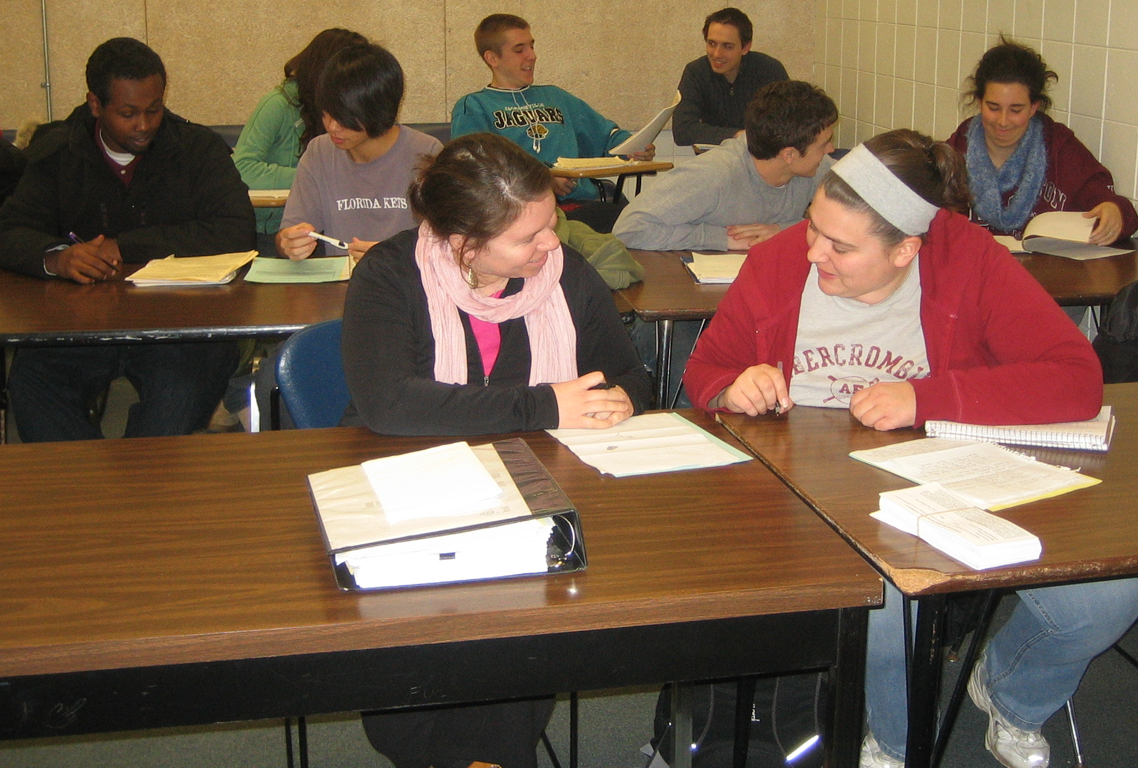  My students working in pairs
energized or tired, I will ask them if something special is happening or commiserate with their tiredness. Often I pass a comic strip around. After these first few moments, we may do one of two things. If it is a group-activity day, I ask the students to number off into small groups of three to four people each. (In a computer lab, I have three students in a group gathered around one computer.) Next, I ask them to very briefly introduce themselves to each other and quickly choose their group roles (coordinator, writer, reader, and coach). Then I give them an invented situation that is related to the kind of writing we are studying at the time, and I ask them to write about it as a group. for example, I might ask them to imagine that they are the heads of several corporations who have come together to write a position statement on a pressing community issue, or to imagine they are speechwriters for a candidate running for office. On the blackboard, I write several steps for them to follow in writing their document, and when everyone is done, each group's result is read to the class. Finally, I offer a brief explanation of how the activity prepares them for an assignment.

If, on the other hand, I devote the hour to discussion and lecture, I usually have one or two changeups. I always try to present material differently than does the textbook, often in a visual manner. I may talk for ten or twenty minutes about the next writing assignment or about writing style, critical thinking, grammar, research, or punctuation. Sometimes I ask students to practice what we have discussed for five or ten minutes on notepads or computers, or I start discussions by asking students to write their own questions. Several times per term, I use a kinesthetic technique that I call a human tableau of writing to introduce a new type of paper: I ask several students to stand in various positions. For example, if we are studying argument involving two or even three opposing viewpoints, I will have two or three students face each other to represent the viewpoints, and I will ask three more students to stand behind each of the central students, to represent supporting information. In addition, once or twice per term, I will have a brief, casual evaluation activity in which students write or speak about what they feel is working and not working in the class, and what they would change or like to see more of.

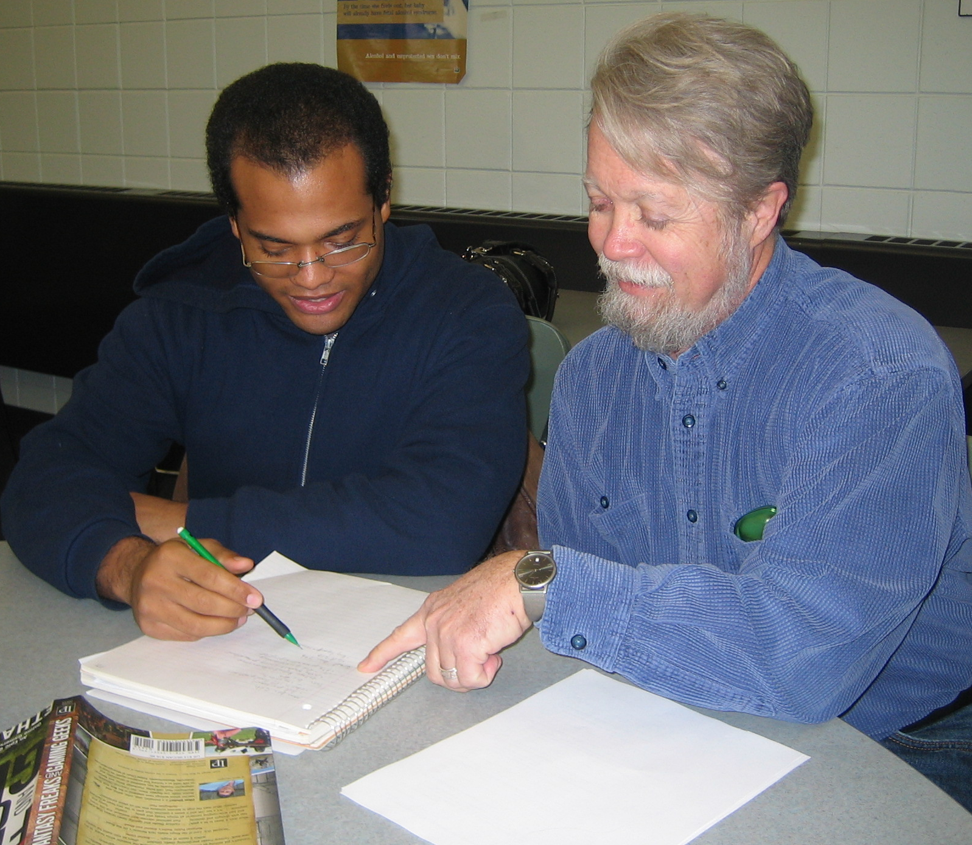  Working with one of my favorite students | In 1983, I was a single father and freelance writer living in Little Falls. Some of my income came from outside work, and when I tried teaching community education and teacher-training courses, I found I love teaching. I enrolled at St. Cloud State for a graduate degree (my third), and I became a TA. After graduating with a 4.0, I worked as an adjunct there. Several years later, I met and eventually married my current wife. She has a tenured position here in the Twin Cities, so my children and I moved here, and I worked at several colleges. In 1996, the University of Minnesota English Department hired me to a full-time, indefinite position teaching first- and third-year composition and an occasional literature course. I like my work, but in the future my job category may be subject to budgetary whims.

As an English instructor, I have taught a wide array of courses, especially in writing. My teaching methods draw on many sources, both experiential and scholarly. My beginnings as a social worker and a freelance writer have been especially helpful. I teach, often in groups, using contemporary methods: process writing, writing across the curriculum, and critical thinking in writing. I have, in fact, worked closely as a colleague with the person who was one of the strongest forces in Minnesota in introducing writing across the curriculum to the state—Chris Anson, formerly at the University—and I am a good friend of Susan Jensen, formerly of IHCC, who introduced WAC to MCCS. I also have team taught with Joel Peterson, who introduced critical thinking to MCCS/MnSCU. In the classroom, I use a relaxed, encouraging approach in which I try to help students have fun, work hard, and try a number of writing methods and skills. My goal is to make them competent writers for other courses and for their professions, and to help them discover how to soar in their writing when they work hard. My reputation is that I am tough, fair, and fun.

Part of my strength in working with students lies in my early experiences in social work. In my twenties, I directed a coffeehouse/drop-in center for young street people in Berkeley, California; I was a teen worker at Northeast Athletic Field in Minneapolis for East Side Neighborhood Services; I have also received professional training in working with teens and in underdeveloped communities. In addition, I have taught multicultural writing at the U and developmental writing at two colleges. Each fall, I continue to teach an overload course on "Becoming a Master Student" for Student Support Services at North Hennepin Community College.

In addition, I have started teaching online as part of one class, and I take my other classes into the computer lab once per week. I have my own extensive course Web site with a 400-page (if printed) textbook (http://umn.edu/home/JeweL001). I also am the administrator of an extensive education Web site: the UM English Department's composition web site, which includes (among many other sections) an "Online Grammar Handbook" of URLs (http://composition.cla.umn.edu).

Inver Hills is a particularly attractive school to work at, in my estimation. The English Department teaches composition as WAC, which, I believe, is best for the greatest number of students. I also have talked with several current and past IHCC English instructors, and I consider some to be among the best in the state. I would look forward to the opportunity to work with you.

Yours sincerely,

Richard Jewell, Education Specialist
English Department, University of Minnesota

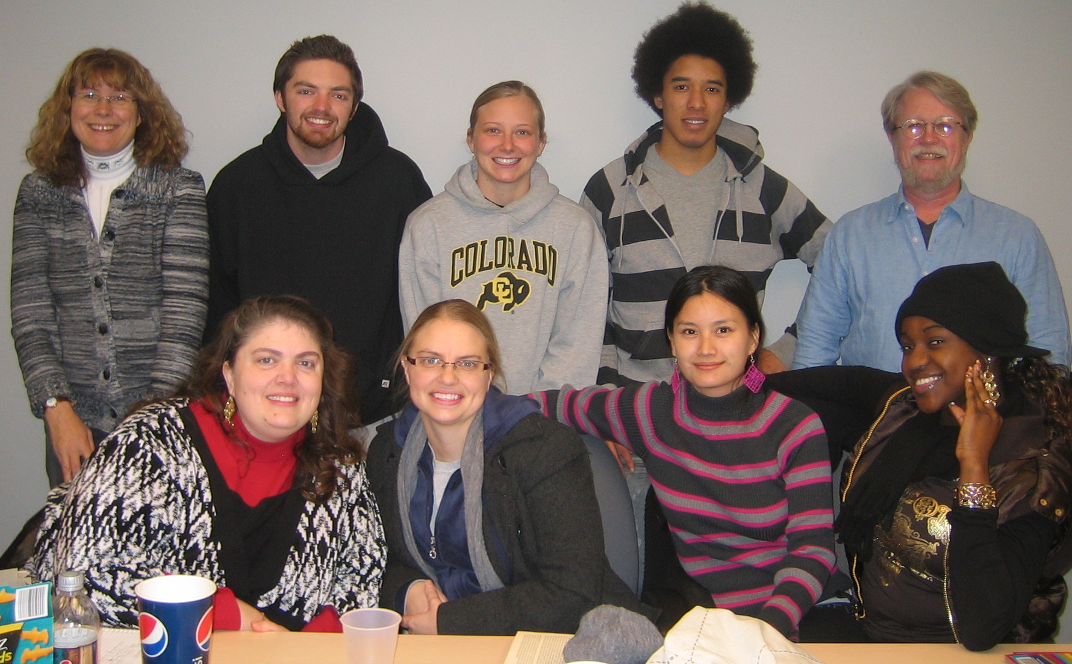

A group of honor society officers with the two of us who are their advisors
(All pictures are used by permission of the students.)

